Celebrating the first birthday of Avi katz
With a Collection of Inspiring and Interesting Jewish Reading Materials
Compiled by Daniel Keren (the proud grandfather)
The ‘Refuseniks’ Who Refused to Compromise on their Jewish Values… Volcanoes on the Sidewalk… Hillel and the Aggravating Erev Shabbos Questionnaire… Learning from a Baby… The Rosh Yeshivah
And the Mailbox… Rabbi Gershon Mendel Garelik, 88, Charismatic Emissary Who Revived Italian Jewry… The Talmid Chacham and The Secular Doctor… A Small Menorah in a Boston Suburb Casts Its Light into Purim… The Power of Pushkas… What to Look for in a Good Wife… The Power of the Shehakol Blessing… Framed Pictures of Tzadikim… The Baal Shem Tov’s Unusual Marriage… The Midnight Mystery and the Halted Plague…18th Century German Hanukah Lamp… Rav of Komemiyus – Rabbi Binyomin Mendelson… True Happiness… Kashrus and Chalav Yisroel (Jewish) Milk… A Grandfather’s Defining Moment of Truth… The Wisdom of Rav Gamliel, Rabbi Blech and the Rebbe… Rabbi Eliezer Silver and the Mikveh for the Refugees… An Italian Bronze Tankard-Form Charity Container… Shabbat is Sacred… The Crying Woman and the Jerusalem Tzadik… The Fancy Glass of Water… Shira’s Unexpected Miracle

The ‘Refuseniks’ Who Refused to Compromise
On their Jewish Values
By Sofya Sara Esther Tamarkin

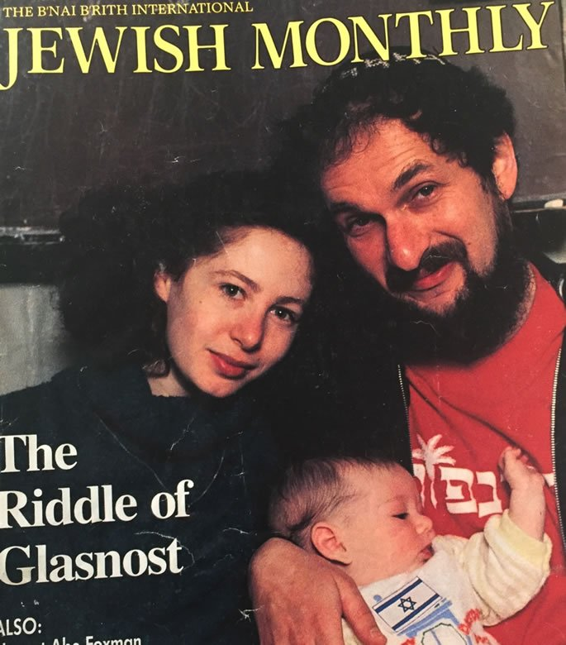
Lev and Marina on the cover of a 1987 American Jewish magazine.

“Remember that in a hall of perfect darkness, if you light one small candle, its precious light will be seen from afar, by everyone.”
— The Lubavitcher Rebbe to Benjamin Netanyahu about his work at the United Nations
Lev Furman was born in Leningrad, now St. Petersburg, in 1947. His father, Mikhail, was a Soviet naval officer and his mother, Bella, a nurse. Despite Soviet prohibitions, Lev had a brit milah, a circumcision, at eight days old, as required by Jewish law. When Lev was 12, his father found a teacher, a Chabad chassid named Avraham Abu, to teach his son basic Jewish ideas. This was a very dangerous decision, as it was considered a stance against the Communist government, which prohibited any religious observance. These secret lessons lasted for a few months before Lev turned 13.

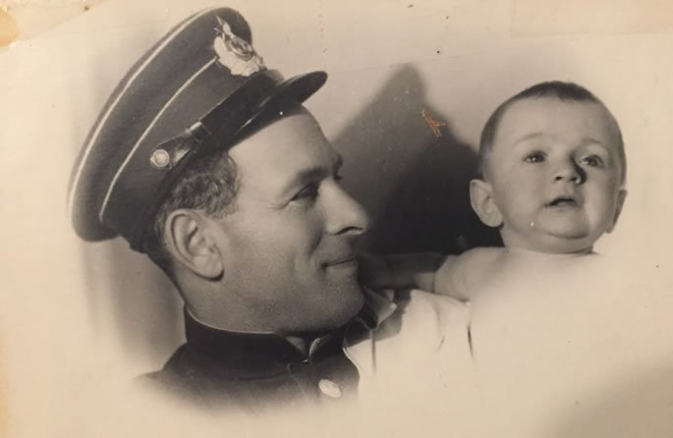
Lev with his navy officer father in 1947.

Lev experienced a Passover Seder in 1970. While this was not yet a fully kosher celebration, it was symbolic of hope and freedom. In 1973, upon Lev’s release from his mandatory year of military service, the Furman family applied for exit visas to immigrate to Israel.
Unfortunately, their request was denied, and the family became known as refuseniks (people who were refused permission to leave the USSR). Being a refusenik was an unofficial life sentence in the Soviet Union; it meant losing jobs and being considered a social outcast by the Soviets. Desperate to earn a living for the family, Lev, an engineer, found a job as a stoker (coal burner), which no skilled worker would be interested in.
Lev wasn’t discouraged by his dismal employment and spent his free time learning Hebrew, eventually becoming a teacher. He also became actively involved with other refuseniks, sharing information and receiving secret packages of religious articles from Israel, Europe and the United States. Such packages included prayer books, Hebrew textbooks, literature about Israel and religious items.

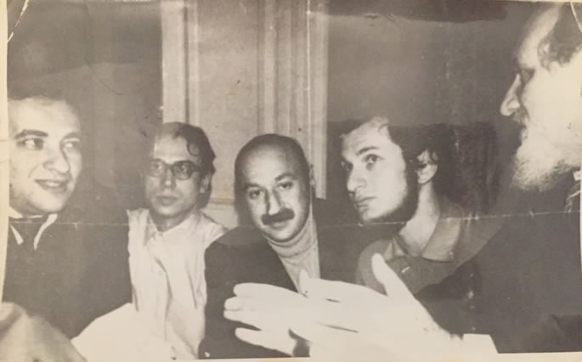
Lev as a young refusenik in Leningrad, 1976, meeting with the Chief Rabbi of Great Britain, Sir Jacobovitch.

In 1974, Lev’s life changed forever when he met a fellow refusenik, Yitzchak Kogan, later commonly known as the“tzaddik (‘righteous person’) of Leningrad.”
Yitzchak came from an observant family. His maternal grandfather, Yossef Tamarkin, was close to the sixth Lubavitcher Rebbe, Rabbi Yosef Yitzchak Schneersohn, and Yitzchak was connected to the Rebbe, Rabbi Menachem Mendel Schneerson. Lev and Yitzchak became close friends, and the Kogan family introduced Lev to their Jewish lifestyle and religious traditions, which in the Soviet Union was a rarity. Around that time, Lev received his first tallit as a gift from the West, along with a magazine called Vozrazdenie, “Revival”. Lev often jeopardized his own safety, eager to help Yitzchak and his wife Sofa with their work on behalf of the Soviet Jews.

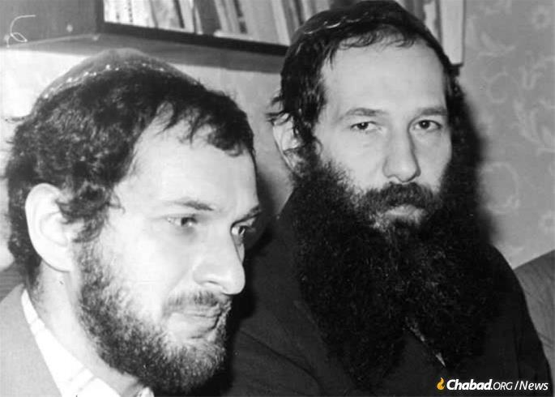
Lev Furman and Yitzchok Kogan at bar mitzvah of Vladimir Fradkin. Leningrad, 1981.

While fighting for his freedom, Lev traveled to major Soviet cities, teaching Judaism to the Jewish youth of the country. In 1976, he participated in a Purim shpiel (play), playing the role of Haman. He and other refuseniks went on tour, traveling from Leningrad to Moscow to perform it.
In 1977, Lev’s father was arrested for supporting his son’s defiance of the Soviet regime and jailed for 10 days. Lev himself was arrested three months later and jailed for a 15-day period. After his release, he continued to teach Hebrew and help Yitzchak Kogan with his work.
In 1978, Lev joined the Kogan family and 50 other guests for his first real kosher Seder. Two years later, Lev began to keep kosher and observe Shabbat. This was a very challenging commitment in the Soviet Union. Jews had no kosher meat in Leningrad until Yitzchak learned how to do shechitah, kosher slaughtering, and later became a shochet for the entire Soviet Union.

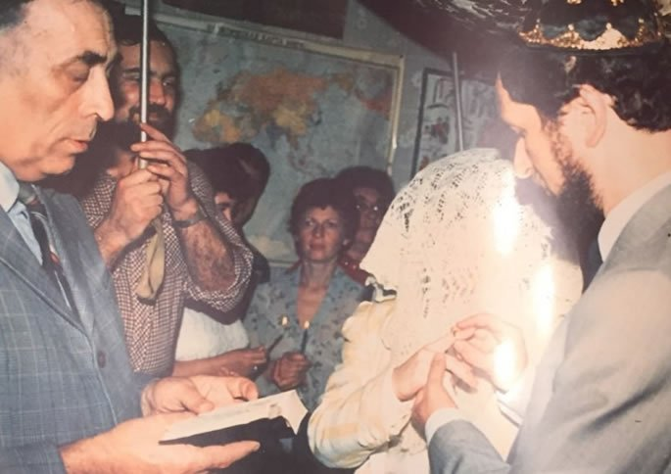
Lev and Marina under the chuppah.

The years 1983 and 1984 were particularly challenging for Lev with many confrontations with the KGB and Soviet police. Lev was often followed and harassed for minor incidents. For example, one day a policeman suddenly appeared when Lev crossed a street at a red light. Two witnesses were generally required to make an arrest. Suddenly, witnesses appeared out of nowhere, clearly strategically planted to offer testimony. Many similar situations were staged to make life particularly difficult for the Furman family.
Searches were often made by the KGB agents. Lev recalls that “Mama had a weak heart. She was completely overwhelmed by these challenges of our fight for freedom. One day, police came with a search warrant and Mama couldn’t get up from her bed. She was so sick. It was horrible.”
Lev remembers how one day Yitzchak asked if Lev was a firstborn son. He was surprised by this inquiry, but Yitzchak explained that there is a ritual called the “redemption of the firstborn son” or pidyon haben. Through this mitzvah, a Jewish firstborn is “redeemed” by a priest 30 days after he is born. Yitzchak insisted that Lev should undergo the pidyon haben ceremony despite his age, explaining to Lev that he himself was a kohen and thus could perform this ritual. All that was necessary was a silver item, so Lev brought an old silver spoon for this occasion.

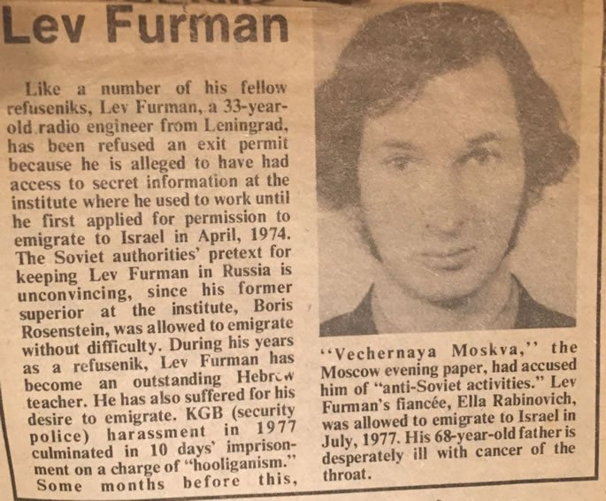
1987 article in an American newspaper.

Lev still cannot fully comprehend the miraculous outcome of that ceremony. Right after he took part in it, the confrontations, searches and arrests stopped.
“The Kogan family taught me so much about my heritage,” says Lev. “I was overjoyed when, in 1987, their family finally received visas to immigrate to Israel. Right before their departure, I met my wife, Marina, at a goodbye party of fellow refuseniks who finally received their exit visas.
“We married two months later under a chuppah. Marina was originally from Kiev. She had been a refusenik since 1979. Her story was much more complicated than mine, because she was not only emotionally tormented but suffered physical confrontations for five years before we met. Right before our initial encounter, Marina wrote a letter, explaining all the abuse she and her mother endured since they applied to immigrate to Israel. I used my connections to the West and sent it to England, where it was broadcast by the BBC. After that international act of defiance, our situation became even more dangerous.
“When Marina was pregnant, the KGB agents made us aware that if we did not give up our fight, neither Marina nor our future child would survive the labor. We hired a doctor, trying to prevent any “accidents,” yet when, on March 6, 1987, my wife went into labor, this doctor never arrived to work. I am still in shock from the events of that day. Later, I learned that while Marina was in labor, someone injected her with an unknown medication. She remembers “floating away.”
This might have been the end, yet G-d intervened on our behalf, and a hospital department head, who was unaware of the KGB plot, miraculously walked into her room after hearing her screaming and ultimately saved two lives. Since no visitors, including husbands, were allowed in Soviet labor and delivery hospitals, I learned about this incident over a very brief phone conversation with Marina. To say that I was horrified was an understatement.

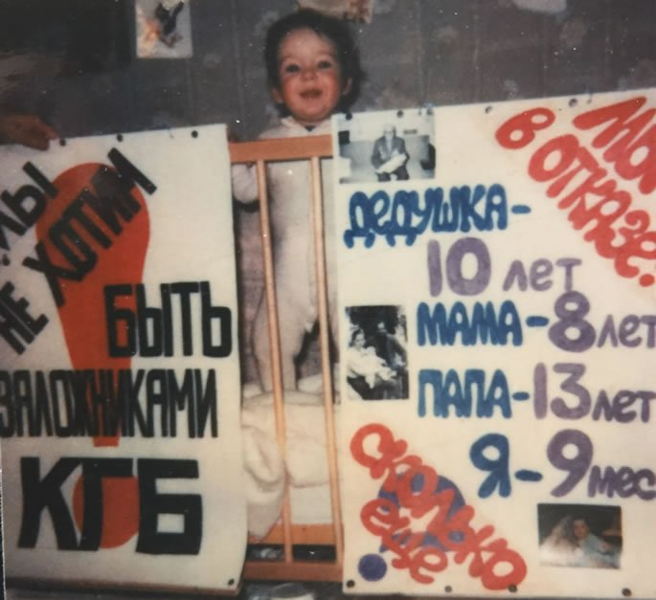
Aliyah, 9 months old, with two posters the evening before a demonstration.

“That day, I wrote a message to my wife on the wall directly opposite her window: ‘Marina, you are my hero.’
“Years later, we tried to find this doctor to thank him for what he did, but unfortunately, he was fired immediately after the incident, and we never had a chance to see him again. We named our baby girl Aliyah, hoping that she would be a living testament to the strength of the Jewish people. The Soviet government didn’t want to register this name, yet once again we protested and continued our fight for freedom.”

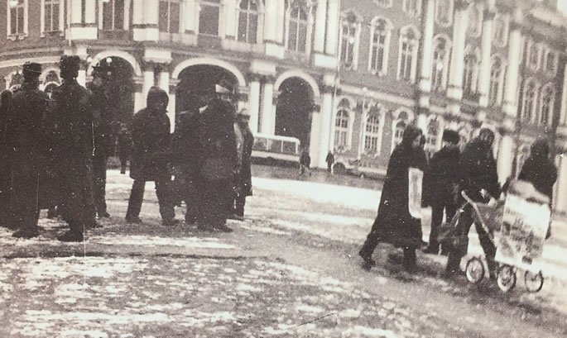
The beginning of the protest on Palace Square . Lev and Marina with the baby in the carriage with the 2 posters. Next to the Winter Palace, a bus is visible. It is waiting to take the family to the police station.

In 1987, during the “Let My People Go” rally in Washington, D.C., the Furmans joined half a million protestors on the other side of the ocean in Palace Square, the site of the 1917 Bolshevik Revolution, where the Furmans held up their handmade posters of their refusenik status. Unsurprisingly, they had been followed by KGB agents and were immediately arrested, along with their baby daughter.
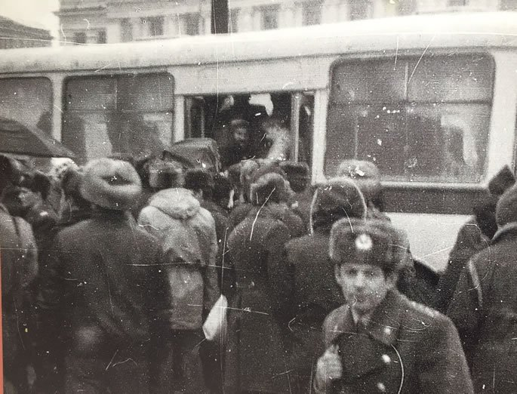
Five minutes into the protest, the family is forced into the bus.

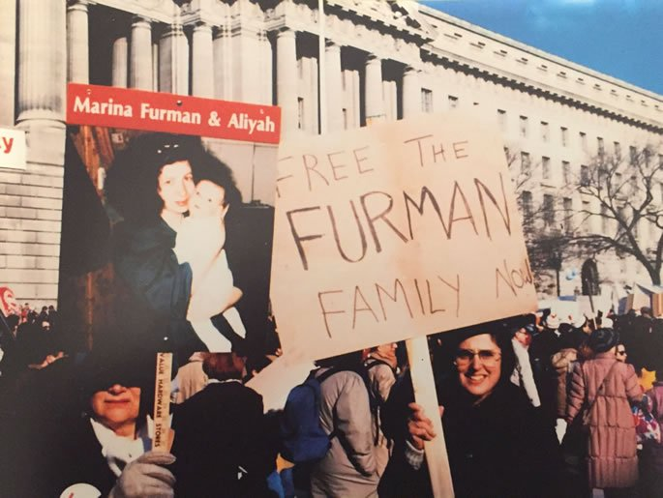
Rally in Washington DC, December 6, 1987. The Furmans were protesting in Leningrad that same day.

At the police station, Marina and Lev were separated from their baby, and they heard her scream in another room. Lev was jailed for 10 days and released on the first day of Chanukah. On the last day of the holiday, the Furmans experienced a Chanukah miracle: They received their exit visas to finally immigrate to Israel!
They landed in Israel on the country’s Independence Day, watching fireworks from the plane. For them, it was their personal Independence Day.

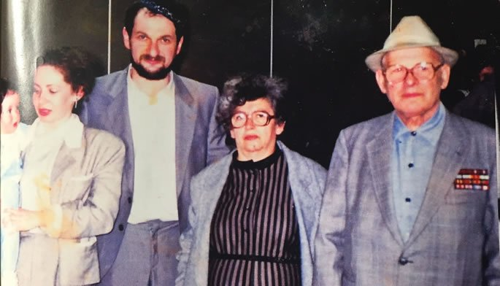
First steps in Israel. L-R: Baby Aliyah, Marina, Lev, mother-in-law Ella, father Mikhail.

The Furman family was greeted by many refuseniks and friends from around the world. It was particularly meaningful and joyous for Lev to be reunited with Yitzchak Kogan.
Sofa Kogan gave simple advice to Marina: “In the Soviet Union, you learned how to survive. Here in Israel, you need to learn how to live.”
The Furmans often think about these profound words. Life went on, and in 1994, the family welcomed their second daughter, Michal, named after Lev’s father. Lev found a job as a Hebrew teacher, working with new immigrants. Marina worked for the United Jewish Appeal, eventually becoming the main speaker for the organization, traveling the world and advocating for the Land of Israel.
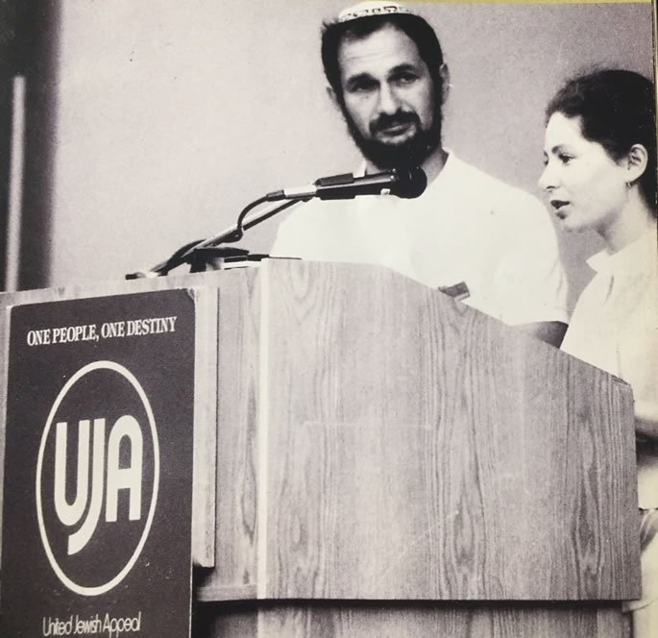
Lev and Marina at the UJA convention on their first trip to the US in 1988.

Yitzchak Kogan continued his work on behalf of the Jewish people. He followed the guidance of the Lubavitcher Rebbe and was given the task to evacuate Jewish children from Chernobyl after the nuclear explosion. Yitzchak facilitated the dramatic airlift of Jewish children from the danger zone to Israel.
Eventually, the Kogan family returned to the former Soviet Union under the direction of the Rebbe to rebuild Judaism after the fall of communism. They were sent to Moscow, where Yitzchak became the chief rabbi at the Bolshaya Bronnaya Synagogue in Moscow.
In 2001, Lev and Marina visited Leningrad, now St. Petersburg, for the first time since their immigration. In an emotional reunion, Lev visited Yitzchak in Moscow. While the streets and the surroundings looked the same, the two friends met in a completely different reality. They were no longer prisoners of communism. They had won their battle, just like the Maccabees in the story of Chanukah. May their legacy be a blessing upon our Nation.

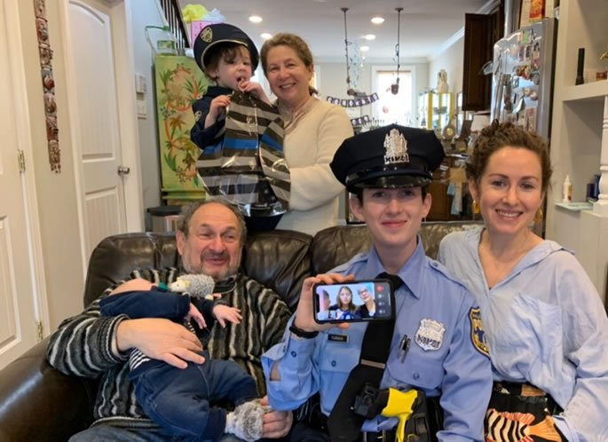
Furman family celebration in honor of Michal becoming a police officer. Pictured: Marina, Lev, Michal, Aliya and grandchildren Coby and Zeev.

Volcanoes on the Sidewalk
By Ari Ben-Ami and illustration by Yocheved Nadell

“Totty, Totty!” said Shimmy breathlessly as he ran into the house after school.
“Hi Shimmy!” Totty said with a smile, looking up from the sefer he was holding. “What’s wrong? Why are you so out of breath?”
“Totty,” Shimmy said, still trying to catch his breath. “We need to go to Hawaii. Can you buy tickets right now?”
Totty almost dropped his sefer. “What? Hawaii? Why? What are you talking about?”
“Ari Holtzbacher just came back from Hawaii!” Shimmy gushed. “The whole family flew there for his little brother’s upsherin. And he was telling us about all of the amazing things they have there: the crystal blue ocean that goes on for miles, tropical rain forests, and volcanoes! Volcanoes, Totty! With real actual boiling hot lava flowing down from them into the ocean. Can you imagine? We have to go right away!”

Why Should We Waste Money on a Trip to Hawaii
“But Shimmy,” Totty said, “I don’t have a hundred billion dollars like Anshel Holtzbacher. And even if we did have that kind of money, why would we waste it on a trip to Hawaii?”
“But don’t you always tell us how important it is to spend time looking at and admiring Niflaos HaBorei? Didn’t Rav Avigdor Miller speak about that a lot? Something that important is surely worth spending extra money, just like buying a beautiful lulav and esrog.”
“Oy Shimmy,” said Totty with a smile. “I love the way you think. But let’s think about this week’s parsha for a minute.”
“This week’s Parsha?” Shimmy asked, slightly confused. “It talks about tzoraas. Oh do you mean because the Metzora has to go out of town? Does that mean traveling is only something people who talk loshon hora do?”
“Not exactly, Shimmy,” said Totty. “Come, let’s go for a walk.”
Totty and Shimmy walked out the front door and down the street. After a minute, Totty stopped. “We don’t need to go to Hawaii to see oceans and volcanoes,” he said, pointing at the sidewalk. “Everything we need is right here.”

Where is the Ocean and Where is the Volcano?
Now Shimmy was really confused. There were no oceans and volcanoes on the sidewalk. There was just a faded hopscotch court that one of the neighbor kids had drawn with chalk.
“I don’t see anything,” Shimmy said.
“Think for a second about what the metzora brings along with his korbon.” said Totty.
“Oh,” Shimmy said. “He brought erez and eizov - I think that was wood from two different trees.”
“Good answer,” replied Totty, “but not exactly. You see eitz erez is cedar wood - and a cedar tree is indeed a big huge tall tree. But eizov is moss, just like you see on the trunk of that tree over there. Why did the Torah tell the metzora to bring these two things?
“So Rav Miller explains that the reason the metzora got punished with the terrible tzoraas is because he forgot to stop and see the greatness of Hashem all around him. He just wasted his time with silly jokes and loshon hora, when instead he could have been admiring all of the wonderful things Hashem put into this world.

Failure to Look at the Wonders of Hashem
“That’s why he needs to bring erez and eizov. Because he failed to look at the wonders of Hashem’s big strong trees and didn’t even pay attention to how amazing these little moss plants are. Do you know that moss seeds - or spores - are so tiny that they get carried by the wind all around the world and everywhere where it’s damp and not too sunny they grow?
“That’s why the moss always grows on the north side of trees in this part of the world - because that’s the side of the tree that gets the least sun, so it is wetter and has more water to support the moss!”
Totty pointed down at the sidewalk once more. "Now look again, Shimmy, and tell me what you see."
“Wow,” said Shimmy. "Look at that grass poking up from the cracks in the sidewalk. I’m sure they didn’t put grass seeds there - there doesn’t look like there is even any soil there!”

“Isn’t it Amazing!”
“I know, isn’t it amazing?” Totty said. “But this grass is actually from the grass you see on the field here next to the sidewalk. Grass may look small, but its roots grow super deep - grass roots can even be taller than you or me! And the roots spread out under the ground and then they push up new blades of grass everywhere.
“Even when there’s a rock-hard sidewalk, they find the tiniest cracks and then push themselves through. And then these little tiny blades of grass help convert the poisonous carbon dioxide that comes out of our lungs back into refreshing clean oxygen for us to breathe!”
“Incredible - such Niflaos HaBorei!” said Shimmy, looking around, and for the first time noticing all of the different types of plants, trees, and birds around them. “It’s like we have our very own Hawaii right here - and we only need to walk a few feet to get there!”

Reprinted from the Parshas Tazria-Metzora 5781 email of Junior Avigdor, a part of Toras Avigdor based on the teachings of Rabbi Avigdor Miller, zt”l.

Hillel and the Aggravating Erev Shabbos Questionnaire

The Gemara (Shabbos 30b) discusses the patience and tolerance of the Sages, who remain silent when they were confronted by those who instigate or make nonsensical comments. It was taught in a Braisa that one should always be patient like Hillel, and the Gemara relates a story.
There were two people who made a bet with each other, that anyone who would be able to aggravate Hillel to the point that he reprimands them, will win four hundred zuz.
One of them said, “I will aggravate him.” He waited for Erev Shabbos, and as Hillel was washing his hair, he went to Hillel’s front door and demanded, “Where is Hillel? Where is Hillel?”

“My Son, How Can I Help You?”
Hillel wrapped himself in his garment and went out to greet him, and said, “My son, how can I help you?”
The man said, “I have a question to ask.”
Hillel responded, “Ask, my son, ask.”
The man said, “Why are the heads of the people from Bavel oval-shaped?” He was attempting to insult Hillel, who was from Bavel. Hillel said to him, “My son, you have asked a significant question. The reason is because they do not have clever midwives. They do not know how to shape the child’s head at birth.”
The man left and waited a little, and then a short while later, he returned to look for Hillel. He again demanded, “Where is Hillel? Where is Hillel?” Again, Hillel wrapped himself in his garment and went out to greet him. Hillel said to him, “My son, what do you seek?”
The man said, “I have a question to ask.”
Hillel replied, “Ask, my son, ask.”

A Question about the Residents of Tadmor
The man asked, “Why are the eyes of the residents of Tadmor bleary and hazy?”
Hillel said to him, “My son, you have asked a significant question. The reason is because they live among the sands and the sand gets into their eyes.” Once again, the man left, waited a little, and then returned, and said, “Where is Hillel? Where is Hillel?” Again, Hillel wrapped himself and went out to greet him.
He said, “My son, what would you like?”
The man said, I have a question to ask.
Hillel replied, “Ask, my son, ask.”
The man said, “Why do people from Africa have wide feet?”
Hillel said to him, “You have asked a significant question. The reason is because they live in marshlands and their feet are widened to enable them to walk through those swampy areas.”
The man said, “I have many more questions to ask, but I am afraid to, so that I don’t get you angry.”
Hillel sat down before him and he said, “All of the questions that you have to ask, ask them.”

The Questionnaire Gets Angry
The man got angry and said, “Are you Hillel, the one people call the ‘Nasi of Yisroel’?”
Hillel replied, “Yes.”
The man said, “If it is you, then may there not be many like you in Israel!” Hillel responded, “My son, for what reason do you say this?”
The man answered, “Because I lost four hundred Zuz because of you!” Hillel said to him, “Watch yourself in the future and avoid situations like this. It is worth it for you to lose four hundred Zuz, and even to lose another four hundred Zuz on account of me, but Hillel will not get upset for any reason!”

Reprinted from the Parshas Tazria-Metzora 5781 email of Torah U’Tefilah as compiled by Rabbi Yehuda Winzelberg.
Learning from a Baby

A few years ago, a couple in Bnei Brak was blessed with a new baby girl. After the baby was born, she would not stop crying and would not nurse from her mother or take any bottles. This concerned the head nurse, who looked in the baby’s mouth and discovered that her lip and tongue were attached. This was a very severe case of this particular deformity. The nurse set up a feeding tube to give the baby necessary nutrients.
Right away, the parents discussed between themselves that though this was a tragic occurrence, it is from Hashem and clearly symbolic. Since the defect occurred in the baby’s mouth, they took upon themselves to strengthen their shemirat halashon—guarding one’s tongue and vowed to be more careful and refrain from speaking lashon hara. They also took upon themselves to learn two halachot a day of shemirat halashon and to make sure not to speak or hear lashon hara as a zechut for the refuah shelemah of their newborn baby.

Searching for the Best Surgeon
The parents then researched who was the best surgeon to perform this complicated procedure to fix their daughter. The parents brought their baby to the surgeon for the appointment a week after they took upon themselves to refrain from speaking lashon hara. The surgeon looked into the baby’s mouth. He looked and looked inside with a serious expression, not saying a word, which made the parents anxious. Finally, the surgeon said, “I really don’t know why you are here, there is absolutely nothing wrong with your daughter’s mouth. Her tongue and lips are perfect, exactly the way they should be.”

A Frightening Idea
Rabbi Frand brings down a frightening chiddush—idea from the Chovot HaLevavot. The idea is that if Reuven was to slander Shimon, it is said that all of Reuven’s mitzvot and merits that he accumulated up until that point will be transferred over to Shimon, and all of Shimon’s sins will be transferred to Reuven. The Chovot HaLevavot goes as far to tell a story about how Shimon sent Reuven a fruit basket as a gift for Reuven saying lashon hara about him, to thank and repay Reuven for transferring all his merits over to Shimon.

Reprinted from the Parshat Tazria-Metsora 5781 email of Jack E. Rahmey based on the teachings of Rabbi Amram Sananes.

The Rosh Yeshivah
And the Mailbox

Tefilos in the Manchester Yeshivah were meticulous and lengthy, yet long after the last Kaddish for Maariv was over, the Rosh Yeshivah, Rav Yehuda Zev Segal, zt”l, would finally complete his Davening.
A student would then give the Rosh Yeshivah a ride home. However, for Rav Segal, the ride was not a gap in the day’s schedule. He got into the car carrying a bundle of letters to mail. It used to be that when the boys had letters to mail, they would give their letters to a Bachur named Eliezer to mail for them. One time, when they brought the letters to Eliezer, Rav Yehuda Zev asked if he could take them instead. The Bachurim hesitated. Surely, this wasn’t Kavod for the Rosh Yeshivah! But who were they to argue?
Even the Yeshivah’s driver asked if he could go out into the cold night instead of the Rosh Yeshivah to mail the letters, but Rav Yehuda Zev became very animated, and exclaimed, “I would give you a million pounds for this Mitzvah! Mailing the letters is a Chesed for the Bachurim, and it brings great joy to their parents, who live far away.”
So, every evening, the car would stop by the mailbox on the side of the road, and the Rosh Yeshivah would emerge and mail the letters. He would say “Hineni Muchan U’Mezuman… Behold I am prepared to do a Mitzvah of Chesed!” and he would mail the letters. When he got back in the car, he would say, “Look how Hashem gives Olam Haba away! For an act that is so small, you get so much!”
Reprinted from the Parshas Tazria-Metzora 5781 email of Torah U’Tefilah
Rabbi Gershon Mendel Garelik, 88, Charismatic Emissary Who Revived Italian Jewry
By Dovid Margolin

The quintessential Chabad Chassid

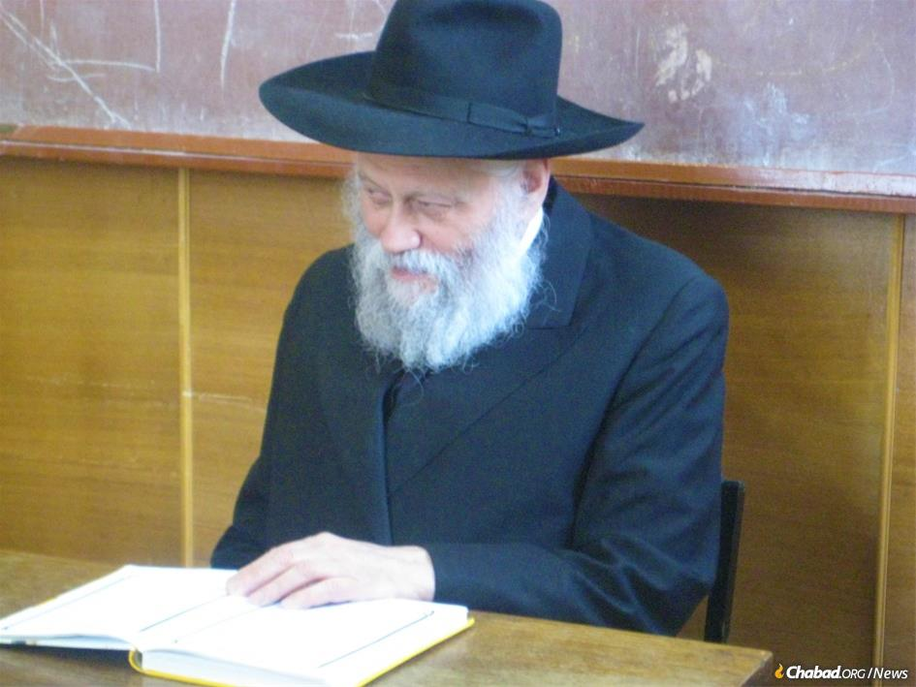
Rabbi Gershon Mendel Garelik, the head Chabad-Lubavitch emissary in Italy, passed away on Shabbat at the age of 88. The charismatic rabbi and his wife, Bassie Garelik, were sent by the Rebbe to Milan Italy, in 1958, and would over more than half a century of work change the course of Italian Jewish life. (Credit: Jewish Community of Kharkov)

With his debonair looks and mischievous smile, Rabbi Gershon Mendel Garelik never quite fit the mold of pulpit rabbi. Instead, from the moment he arrived in Milan, Italy, in late 1958, he blazed a new role: that of emissary. This was the part Garelik was born to play, and in the deeply devoted, ever-joyous way that he filled it for more than 60 years, he wasn’t just a pioneer, he was a star.
Garelik, who passed away on Feb. 13 at the age of 88, and his wife, Bassie, were newlyweds when the Rebbe—Rabbi Menachem M. Schneerson, of righteous memory—sent them to establish and direct Chabad-Lubavitch of Milan in December of 1958. There were barely more than a handful of emissaries throughout the world at the time.
He was Soviet-born, having by his 14th birthday lived through religious persecution, his mother’s death, the privation of war and illegal escape through the Iron Curtain. She, on the other hand, was an American, born and bred with many of the amenities Americans naturally take for granted.
Yet from the first day of their marriage, they knew all they wanted to be were the Rebbe’s emissaries to whatever corner of the earth he’d send them. Together, they’d become the archetypical Chabad emissary couple, to be followed by generations of emissaries.
For a Chassidic couple living in New York in the 1950s, Italy was as far away and foreign as the moon, but to the Gareliks, the place that would be their new home was incidental compared to the mission. He first got word of his posting from the Rebbe’s chief secretary, Rabbi Chaim Aizik Mordechai Hodakov, after casually bumping into him in Lubavitch World Headquarters at 770 Eastern Parkway in Brooklyn, N.Y.
“I was walking into 770, and as I arrive, Rabbi Hodakov comes over to me and says, ‘The Rebbe wants you to go to Europe,’” Garelik would recall in an interview with Jewish Educational Media’s (JEM) My Encounter with the Rebbe oral-history project. “I asked, ‘Where in Europe?’ and he says, ‘What’s the difference? Let’s say Italy—Milan.’ ” Within two months the couple was on their way.
What at the time for them was but a distant dot on the map was, in fact, a Jewish community consisting mostly of Holocaust survivors—good, hard-working Jews who had lived through the worst of humanity and understandably believed that it was probably best not to wear their Judaism on their sleeves. The men and women in Italy knew Jewish life was important—after all, it was they who first asked the Rebbe to send them a young rabbi—but in the Gareliks, they got something unexpected. Instead of a rabbi who stuck to ceremonials and a rebbetzin who quietly supported him, they discovered a dynamic couple who over the course of more than half a century would reshape the very meaning of Jewish life in Italy.
“The European Jewish communities were devastated after the Holocaust,” says Walker Meghnagi, a prominent Italian businessman and past president of the Jewish Community of Milan. “Rav Garelik took Milan and built Jewish life up from scratch. He had an ability and capacity to interact with everyone, different people, but with each one in a very deep way.”
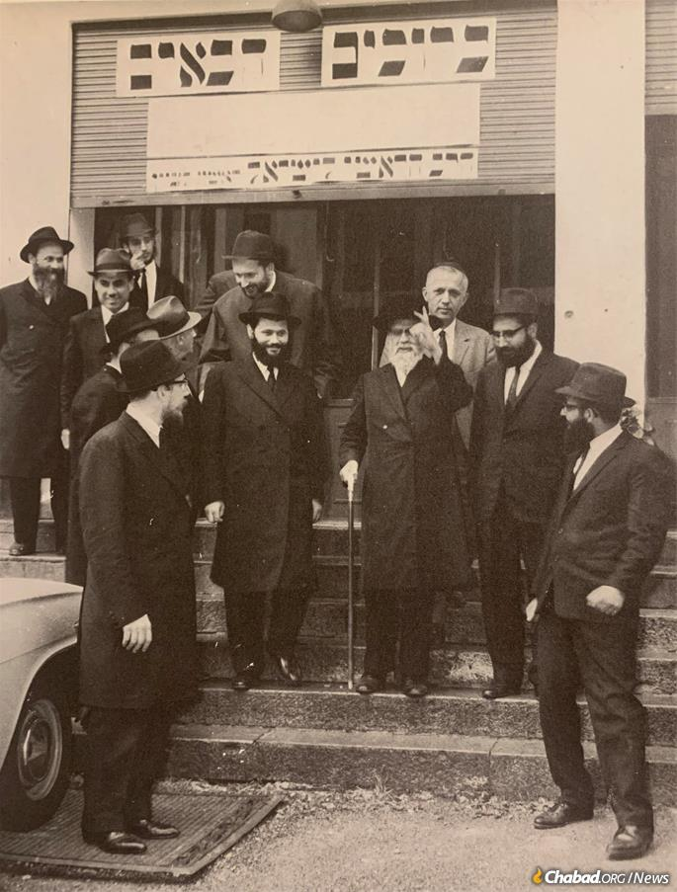
Garelik is remembered by Italian Jews as a man of vision, who did not see Jewish life in post-war Europe as it was, but as it could be. Pictured here (center, left) together with then-Sephardic chief rabbi of Israel Rabbi Yitzchak Nissim on the latter's visit to Camp Gan Israel Italy in the mid-1960s.

“You can see what an impact he had from the reaction to his passing from Italian Jews of all types,” adds Loni Mevorach, current president of the Ohel Yaakov synagogue Garelik led since 1958. “He always had a big vision, an unbelievable vision. He always saw the possibilities—both in the people around him, and in what Jewish life in Italy could look like. And even when he was 10 years ahead of everyone else, he was always right.
“We miss him already.”

Hunger, War and Escape
The fourth of five children of Rabbi Chaim Meir and Rivkah Leah Garelik, Gershon Mendel Garelik was born on May 14, 1932 (8 Iyar, 5682) on a Jewish agricultural settlement in Crimea, Soviet Ukraine. Crimea had served as an early iteration of the plan for a Soviet Jewish homeland, and with the dawn of Stalin’s project of forced collectivization, many Jews were resettled there and taught to farm.
Rabbi Chaim Meir was among a number of Chabad Chassidim sent to Crimea by the Sixth Rebbe—Rabbi Yosef Yitzchak Schneersohn, of righteous memory—to risk their lives by serving its religiously orphaned Jewish farmers as rabbis and shochatim. By the time the younger Garelik was born, famine brought on by collectivization had swept through Ukraine, and hunger was a routine part of his youth. During those years, an older brother of his passed away.
In the late 1930s the family moved to Kharkov, where just before the outbreak of World War II, Garelik’s mother fell ill and passed away. Years later, after the fall of Communism, Garelik returned to the city in the hopes of finding his mother’s burial place. He never did.
Following Hitler’s invasion of the Soviet Union in June of 1941, the surviving members of the Garelik family fled Kharkov for Soviet Central Asia. Garelik would later recall that at some point during the long and unpredictable journey, the train stopped alongside a field of strawberries. Starving, the children—Gershon Mendel among them—began collecting the berries, but before they could eat them, their father stopped them. The poverty of Communism meant that he wasn’t familiar enough with strawberries to know whether they grew on what would be considered a tree or a bush, and so he had to ascertain what blessing one is to make on them.
Their first stop was the city of Alma-Ata (Almaty), Kazakhstan, where the young Gershon Mendel first crossed paths with the Rebbe’s parents, Rabbi Levi Yitzchak and Rebbetzin Chana Schneerson. Rabbi Levi Yitzchak had five years earlier been sentenced to exile in a barren village in Kazakhstan, where he was joined by his wife, before being allowed to move to Alma-Ata in early 1944. Much to his everlasting regret, the younger Garelik never saw Rabbi Levi Yitzchak—his father did not want to take so young a child to prayers with the rabbi for fear of the Soviet secret police—though he would eventually form a close relationship with Rebbetzin Chana. When, years later in 1960, he and his wife named their first son Levi Yitzchak after the Rebbe’s father, Rebbetzin Chana sent Bassie Garelik a warm note of thanks.
From Alma-Ata, the Gareliks headed to Tashkent, Soviet Uzbekistan, where Garelik’s bar mitzvah took place in the spring of 1945. While the celebration consisted of a small group of Chassidim sitting down after morning prayers with a small bottle of spirits and some herring, the simple scene of Chassidic brotherly love would be forever etched in his mind.

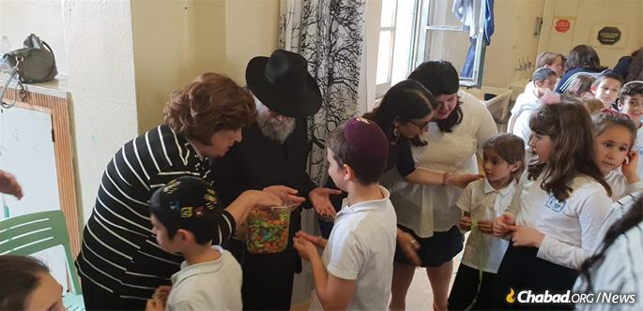
Rabbi and Rebbetzin Garelik distributing candy to students of the Chabad day school in Milan, Italy.

Between the Soviets’ preoccupation with the war effort and the backwater nature of Central Asia, Jewish life was somewhat easier there, but it did not come without fear nor danger. Garelik, a student in Tashkent’s underground cheder, was once caught by a police officer transporting black market wool intended to help his family survive, resulting in his being taken to a holding cell and kept there for hours.
His education in the Jewish underground served him well, and he refused to respond to any questions regarding his name, age, family or friends; eventually, he was bailed out by another member of the Tashkent’s Chassidic community. Towards the end of their time in Uzbekistan, Garelik traveled to Samarkand and joined the city’s clandestine branch of the Tomchei Temimim—Lubavitcher yeshivah that had been established at the beginning of the war. He remained there until the beginning of 1946, when together with most of his family he traveled to Lvov, Ukraine, in the hopes of escaping Russia forever.

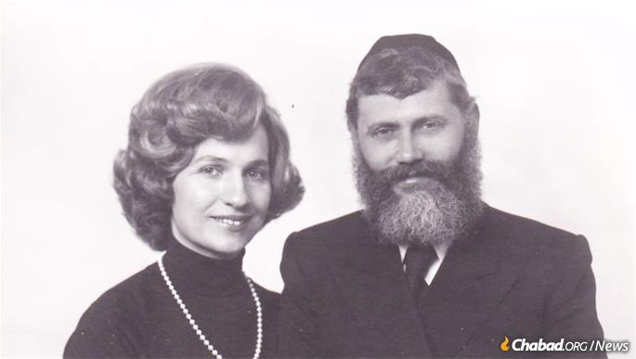
Together, the Gareliks became the archetypical Chabad emissary couple paving the way for generations to follow.

This was the era of the Great Escape, when some 1,000 Lubavitcher men, women and children escaped Russia using purchased or doctored Polish identity papers. Among the masterminds of the vast operation was R’ Leibel Mochkin. That summer of 1946, as the Gareliks stood in Lvov’s train station hoping to soon board and escape to the West, Mochkin approached Garelik’s two sisters, Hadassah and Yocheved, and asked that they both take a taxi immediately to an apartment in town to help escort an elderly woman to the station.
The girls were shocked by the thought of delaying their escape by a moment, but agreed. At the apartment, they found another of the organizers, Sarah Katzenellenbogen (known as Mumme Sarah), trying to convince the aristocratic-looking woman to make the dangerous journey. Seeing the young women enter her room, the elderly woman turned to them and asked who they were.
“We are the daughters of R’ Chaim Meir Garelik, the Rebbe’s emissary to Crimea,” Garelik’s sister Yocheved Zalmanov would later recall responding. “Suddenly, her noble countenance brightened and she said, with conviction ‘With these children I’ll go! … .’ ”
The woman was Rebbetzin Chana, who would end up traveling with them all the way to the displaced persons camp in Pocking, Germany. There young Gershon Mendel and a friend worked hard to make sure she would be as comfortable as possible under the still-difficult conditions.
Though Gershon Mendel and his family were free, an older brother, Bentzion, was stuck behind. Bentzion would only be granted permission to leave the USSR in 1972.

From Israel to New York
Around 1949 the Gareliks arrived in Israel, settling in the newly-founded village of Kfar Chabad, with Gershon Mendel enrolling at the yeshivah in nearby Lod. He spent four years studying in Israel, during which time Garelik also worked at reaching out to his fellow Jews, particularly within the immigrant Yemenite community.
Garelik had always wanted to travel to New York so that he could see the Rebbe for himself, but found it nearly impossible to obtain an Israeli exit visa. In the mid-1950s he finally wrote a long letter to the president of Israel, Yitzchak Ben-Zvi, eloquently describing his Chabad upbringing in the Soviet Union and requesting help in his effort. “It is not a secret that the living force behind the [dangerous] Lubavitcher [underground] enterprise was the Lubavitcher Rebbe … ,” he wrote. “[I]t is my strongest desire to have the privilege of my life and meeting my spiritual father, the Rebbe … .”
The sympathetic response from Ben-Zvi’s secretary did not help and merely referred him to the proper authorities, but Garelik did end up receiving permission and arrived in Brooklyn in 1955.
The years that Garelik spent in the immediate vicinity of the Rebbe would be life-defining ones for him. Back then, the crowds at 770 were incomparably smaller, and the students studying at the yeshivah had a front row seat as the Rebbe set about building upon his vision to change the world. Like Garelik, many of the young students had lost parents or family in Europe, and the bonds they formed with the Rebbe reflected his deep care and attention for each of them.
Garelik excelled in his studies, eventually being appointed a Chassidic mentor at the Chabad yeshivah in Newark, N.J. In 1958, he married Bassie Posner, whose parents had been sent to Pittsburgh by the Sixth Rebbe to establish the city’s first yeshivah day school. The Rebbe officiated at the chuppah ceremony in New York, and then the immediate family flew to Pittsburgh where the rest of the wedding celebration took place.
Though historically the concept of being sent as an emissary by the Rebbe was by no means a new one in Chabad, during this period the Rebbe began stressing it in a new way, laying out the foundations of his revolutionary model of shlichus as the world knows it today.

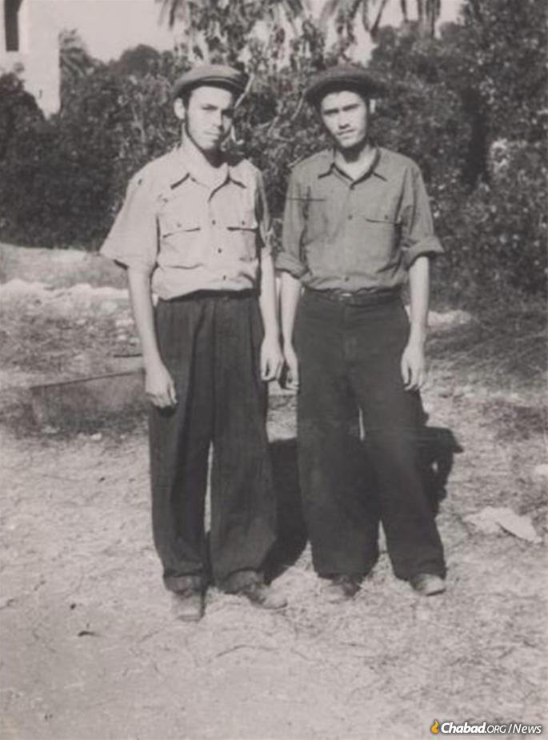
Garelik (left) together with his lifelong friend Rabbi Leibel Raskin (himself a pioneering emissary in Casablanca, Morocco,) in the early 1940s in Tashkent.

“A Jew cannot suffice with just bringing light into his own home,” the Rebbe explained in Yiddish at a gathering in the winter of 1958. “But he must reach out to one Jew, and another Jew and yet another Jew.”

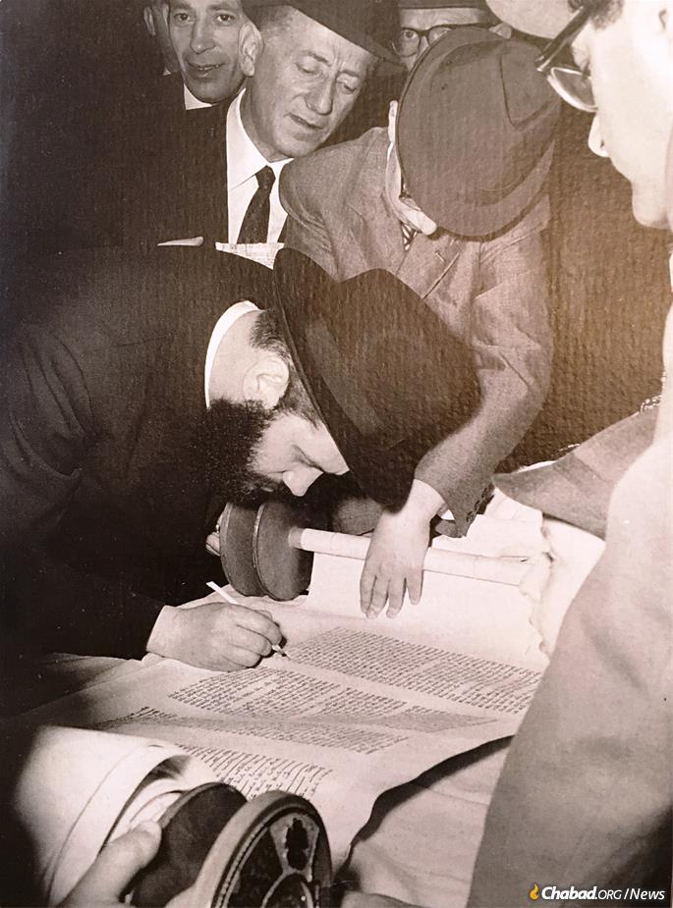
A young Rabbi Garelik at a Torah-scroll completion ceremony in Milan.
With the Rebbe now sounding the theme of young couples being ready to be sent out to serve Jews anywhere in the world, the newlyweds immediately signed up.

The Call of Ufaratzta
The Gareliks might have known little of Milan, but Milan’s survivor Jews had already established a connection with Lubavitch by way of the Zippel family. The four Zippel brothers—Shlomo Yosef, Chaim, Avraham and Gershon—were Polish Jews who had lived in Italy, spent time before the war in Germany and then returned to Italy.
They survived the war by escaping into Switzerland on foot before deportations started. After the Holocaust, during which they had lost one sister and her children, who had been turned back by Swiss authorities, they established a little synagogue in Milan called Ohel Yaakov. Milan was already home to a Lubavitcher shochet, and Ohel Yaakov’s rabbi was an elderly Lubavitcher Chassid as well. When the rabbi left for Australia, the Zippels turned to the Rebbe, asking that he send them a new rav for their small community.
While both Gareliks yearned to serve as emissaries, the enormity of moving so far from the Rebbe was difficult to grapple with. This was especially so for the young rabbi, who had longed so much to be in the Rebbe’s environs and thrived when he had finally gotten there. It was the Rebbe’s promise that those who agreed to do the burgeoning work of Lubavitch—no matter the geographic distance—who would be closest to him that sealed the deal.

A Private Audience with the Rebbe
On November 23, 1958—the day the Gareliks headed to the airport—they first had a private audience with the Rebbe, who then saw them off. On December 1, that year corresponding to the 19th of Kislev, an auspicious day on the Chassidic calendar, the Gareliks arrived in Milan to begin their work.
“Harav Gershon Mendel Garelik arrived today in Milan and is marking the 19th of Kislev there,” the Rebbe announced at the farbrengen gathering in New York. “Is there a close relative here who can say l’chaim on his behalf?”
For the next year at least, a farbrengen would not pass by without the Rebbe publicly evoking the Gareliks by name, telegraphing to everyone in the room and beyond that in his book, there was no higher calling than serving their fellow Jews, even or especially if they were overseas and far away. It was his call for ufaratzta, or “to spread out,” in the words of Bereishit, “westward and eastward and northward and southward.”

Thinking Big
Daniella Mevorach is Loni’s wife and Avraham Zippel’s daughter. To hear it from her, there were two chapters of post-war Italian Jewry: pre-Garelik and post.

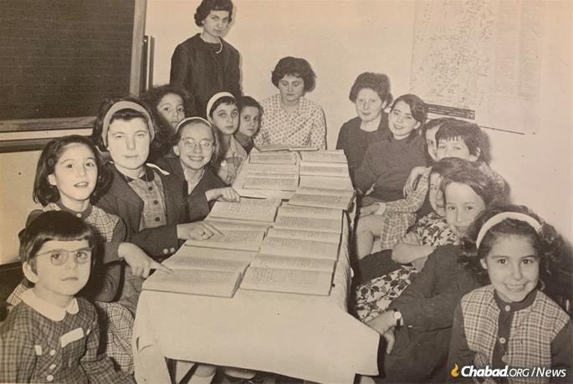
A Torah class at Chabad's new Jewish school in Milan in the mid-1960s.

“Initially, my family’s Judaism was that of the survivors,” she explains. They were observant, much more so than many other Jews around them, but in a prudent and unassuming way. “Then Rabbi Garelik came and he had a special vision. It is one thing to be Jewish in your little shtiebel, where you only see and are seen by those who come there, but Rabbi Garelik came with his Chassidic garb and said, ‘This is how I am going to go meet the president of Italy.’ That was the atmosphere we ended up growing up in.”
The Gareliks, Rabbi Gershon Mendel especially, thought big. When the Zippels, who undertook to cover the young rabbinic couple’s expenses from the start, showed the Gareliks a two-bedroom apartment, Bassie thought it was perfect for a newlywed couple. But the rabbi took a look and immediately said no.
“So they took us to show us another apartment,” Bassie Garelik recalled in an interview with JEM. “It was very big, in terrible condition, very primitive. We walk through the house and my husband says, ‘This is more ufaratztadik [i.e., expansive].’ I [just] got two [long] tables and 50 chairs, this way we should be able to host gatherings.”
Garelik had many natural traits that helped the mission along. He had a magnetic personality, glimmering eyes and a genuinely kind soul. He did not care for petty arguments and did not engage in them. Daniella Mevorach recalls some early synagogue politics, when newcomer Polish Jewish survivors who prayed using the Chassidic Sfard prayer rites did battle with the older generation who sought to continue using the Ashkenazi rites the synagogue had used from its establishment. “Rabbi Garelik was above all such things,” she says. “These were not his problems.”

Morning line-up in the ancient sun-baked courtyard at Camp Gan Israel Italy, which since 1976 has been hosted at Villa Bozio, sculptor Jacques Lipchitz's former home and workplace in Tuscany. (Photo: Batsheva Helena Goldreich for Chabad.org).

His concern was the highly acculturated and increasingly assimilated nature of Italian Jewry. The Rebbe’s secretary, Rabbi Hodakov, had instructed the couple to focus on Jewish education for youth, but when Bassie sought to expand her successful new preschool into a full day school, it was met with resistance.

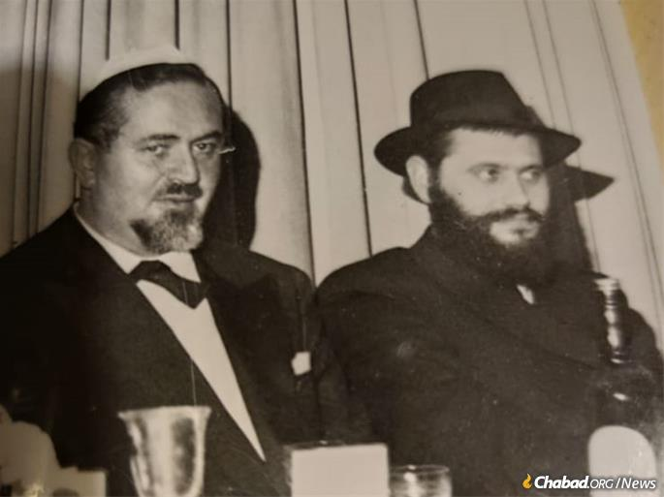
Avraham Zippel, one of the four Zippel brothers who played a key role bringing the Gareliks to Milan and sustaining Jewish life there for decades, sits alongside Rabbi Garelik at a family gathering. Credit: Zippel family.

“It was all uphill,” she told Chabad.org in a 2018 interview. “A full Jewish school was seen as something from the past; it was just too much.” When she sought to open a Jewish summer camp in the summer of 1959, she found herself facing the same attitude. With her husband’s full support, she persisted. Mevorach’s uncle Shlomo Yosef (Carlo) Zippel purchased a vacation home on Lake Lugano and that summer the first Camp Gan Israel in Europe opened its doors. It had a grand total of 10 campers, but back in New York, the Rebbe was lauding the pioneering work.
“From this we are able to see how much can be impacted,” the Rebbe said, speaking in Yiddish about the Gareliks’ general mission in Italy. “ ... A lone couple sets out, they establish a school for boys and a school for girls, teach classes to adults ... [She is] a young woman born in America, [he] a young man born in Russia, G-d Almighty ... introduces them to each other in the United States, and after that they’re sent—farshikt [exiled], so to speak—to Magna Graecia, and there they accomplish all there is to accomplish, and their ‘arms remain outstretched [to accomplish more]’ ... .”

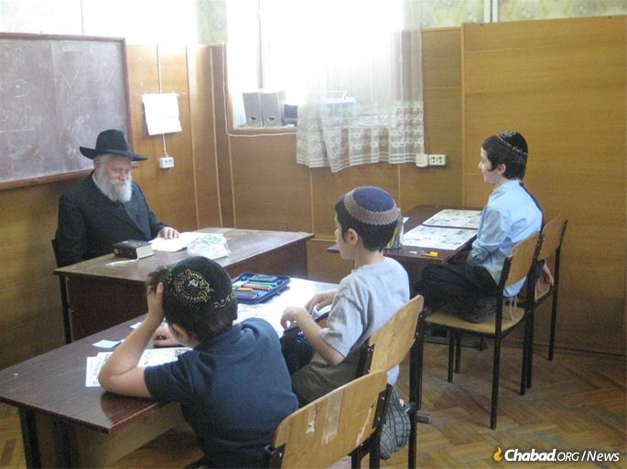
Garelik was beloved by young and old, pictured here with students at the Jewish school in Kharkov, Ukraine. (Credit: Jewish Community of Kharkov)

Indeed, the summer camp, which since 1976 has been hosted at Villa Bozio in Pieve di Camaiore, Tuscany—the former home and workshop of the famed Jewish sculptor Jacques Lipchitz, whose family donated it to Chabad of Italy after his passing—has had a deep impact on generations of Italian Jews. “The experience [of Jewish summer camp] stays with you,” Amy Tesciuba of Rome said in 2018 of his years in Gan Israel beginning in the late 1970s. “It grows with the person.”
The Rebbe saw what would eventually be, and, recognizing the difficulties that came with starting something new, constantly sent his warm encouragement to the Gareliks. In a 1965 letter to Bassie Garelik, the Rebbe underlined the difference between seeding and planting. Planting a tree is a much more laborious effort than seeding, but the results are longer lasting; the same is so in all human endeavors. “If, therefore, it sometimes takes longer for the effort to come to fruition, this is no reason for discouragement,” the Rebbe wrote in English. “On the contrary, the reason may well be that it is a case of ‘planting,’ where the ultimate results will be infinitely greater.”

Immovably Firm in His Beliefs
While Rabbi Garelik’s easy-going personality endeared him to the Jews of Milan and helped him connect with individuals and officials of all backgrounds, Daniella Mevorach recalls that he was immovably firm in his beliefs.
“Especially in the beginning, Rabbi Garelik knew what he wanted and wouldn’t budge,” she says. “If he thought it was important, or a standard he could not break, it was finished.”
Mevorach credits Bassie Garelik with the unique ability to communicate some of this to the Milanese Jews, who were not necessarily used to so staunchly devout a rabbi. “They worked as a perfect team,” she says. “In general, they were the model of a couple. Rabbi Garelik was an example to all men on how to respect your wife, how to treat her. Their relationship warmed your heart.”

Every Jew Has an Individual Mission
When Loni Mevorach first met his future wife in high school, he was a Sephardic boy coming from a non-observant background. As they got older and the prospect of a serious life relationship came up, Daniella asked him to begin learning more about Judaism. That’s when Mevorach first met Rabbi Garelik.
“I was impressed from when I first met him,” he says. Garelik, says Mevorach, was the rabbi one went to “when you needed to discuss family, business, your children, how to behave, the meaning of life, he was the man. He was the leader to give you that direction.”
He did it on the personal level and he did it on the communal one, over time showing all those around him that every Jew has an individual mission and is part of a collective one, at all times and all places—beginning in Milan.
“He taught everyone that we can be Jewish on the streets and in the squares, this was his big message, his big vision, and everything here changed because of him,” says Mevorach.
Today, there are more than 30 Chabad emissary couples serving Jews across the entire boot of Italy, and Milan itself is home to a vibrant Jewish community.

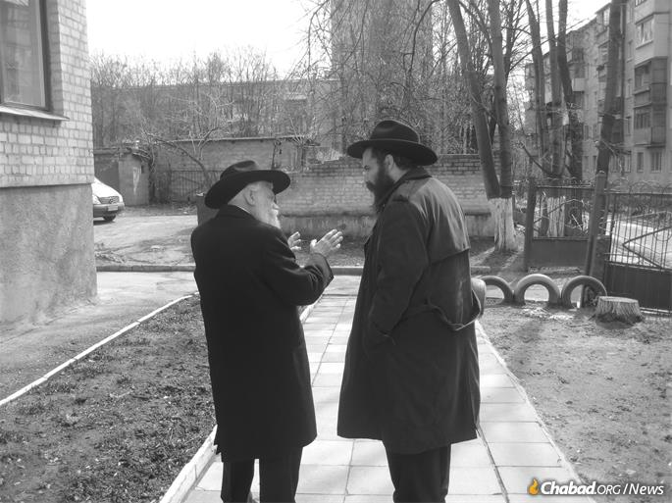
Garelik's magnetic personality, glimmering eyes and genuinely kind soul drew people to him. (Credit: Jewish Community of Kharkov)

From the beginning, the Jews of Milan understood that their wise and farsighted rabbi was a reflection of the man who sent him to Italy: the Rebbe. Garelik himself knew this better than anyone, and he lived with this deepest of all convictions. Through Garelik, countless Italian Jews formed their own relationships with the Rebbe, changing the course of whole families and communities. As for himself, from the moment Garelik landed in Milan he sought any valid excuse to cross the ocean and see the Rebbe again. Eventually he even made good on a prediction he made to his wife in the late 1950s, that there would come a time when he’d visit the Rebbe once a month.
Sometimes, he himself couldn’t explain how it came together. Like the time he lacked the funds to travel to New York, so he just headed to Milan’s airport with the plan of doing his part in the travel. As he sat there, a wealthy Jewish Milanese businessman spotted him. “Ruv,” the man called out in his Galician Yiddish, “where are you going?” “New York,” responded Garelik. “If you haven’t bought a ticket yet, don’t,” said the man. “I’m paying.” And off Garelik went.
At times, this constant travel might have even annoyed some of his congregants. When he once flew to New York against their wishes for the anniversary of the passing of the Rebbe’s father, he stood at the door of the Rebbe’s office hoping to catch a glimpse as the Rebbe went in after the farbrengen. The Rebbe came upstairs to his office, and, seeing Garelik and one of his sons in the vestibule, turned to them and said, “Thank you for coming.” Garelik immediately called Milan to ask his wife to pass on the words to his congregants. When they got the message, they found they could no longer be upset with him. They understood.
The emissary and he who sent him were one.
In addition to his wife, Garelik is survived by their children: Rivki Hazan (Milan, Italy); Rabbi Levi Garelik (Brooklyn, N.Y.); Soshi Shaikevitz (Milan, Italy); Sori Krinsky (Brooklyn, N.Y.); Chani Greenberg (El Paso, Texas); Rabbi Yossi Garelik (Brooklyn, N.Y.); and Moshe Garelik (Brussels, Belgium). He is also survived by many grandchildren and great-grandchildren.

Reprinted from the Parshat Terumah 5781 website of Chabad.Org Magazine.

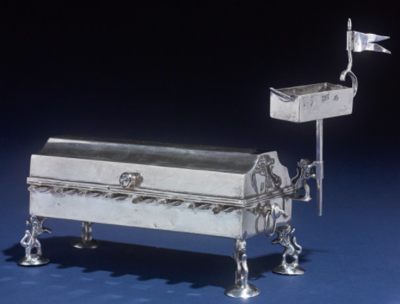

An 18th Century German Silver Hanukah lamp that was auctioned in a 2019 Sotheby Judaica collection from the Arthur & Gitel Marx Collection for $21,250.
The Talmid Chacham
And The Secular Doctor

Rabbi Dovid Sutton notes that when one puts his life at risk for a Mitzvah, Hashem repays that person back. He relates the following story which illustrates how one man’s sacrifice for Shabbos rewarded him, and resulted in a Kiddush Hashem.
A Talmid Chacham (Torah scholar) in Eretz Yisroel did not have much money, and his son took seriously ill on a Shabbos, R”L. He desperately needed a doctor, and there happened to be an excellent doctor, who was a secular Jew, who lived down the block from him.
The doctor was called over to the man’s house and agreed to treat the boy. However, he demanded that he be given a check as payment immediately, before he treated the child. The doctor said, “I don’t trust religious Jews. I will tend to your son only if you give me a check for 500 Shekel right now.”
Halachah clearly establishes that human life overrides Torah law, and so, the father wrote a check in an unusual manner (using a Shinui), and handed it to the doctor.
The doctor looked at the check, and noticed that it was written for 1,000 Shekel. The doctor said, “Maybe you didn’t hear me correctly. I asked for 500 Shekel, not 1,000. Besides, looking around your apartment, it does not appear as though you can afford to pay me extra.”
The Talmid Chacham explained, “To write a check for 500 Shekel, I would have to write three words in Hebrew, ‘Chameish Mei’os Shekel’ (500 Shekel), whereas writing 1,000 Shekel required writing just two words, ‘Elef Shekel’ (1,000 Shekel). In order to minimize the Chilul Shabbos, the desecration of Shabbos, I am prepared to double the amount you asked for.”
The doctor was astounded. He had never seen anything like this in his life! Here was a poor person paying an extra 500 Shekel in order to write ONE word less on Shabbos.
The doctor put the check in his pocket. He took out 500 Shekel and set it down on the table as change, treated the sick child, and brought the check home to show his wife.
After Shabbos, the doctor returned to the Talmid Chacham’s home and said, “I was so moved by what you did today, and I decided that I wanted to learn more about Shabbos and Judaism.” The Talmid Chacham began studying with him, and ultimately, the doctor became a Ba’al Teshuvah!
Reprinted from the Parshas Tazria-Metzora 5781 email of Torah U’Tefilah as compiled by Rabbi Yehuda Winzelberg.
A Small Menorah in a Boston Suburb Casts Its Light into Purim
By Carin M. Smilk

How a rabbi’s unexpected visit reignited Jewish practice in a family’s life
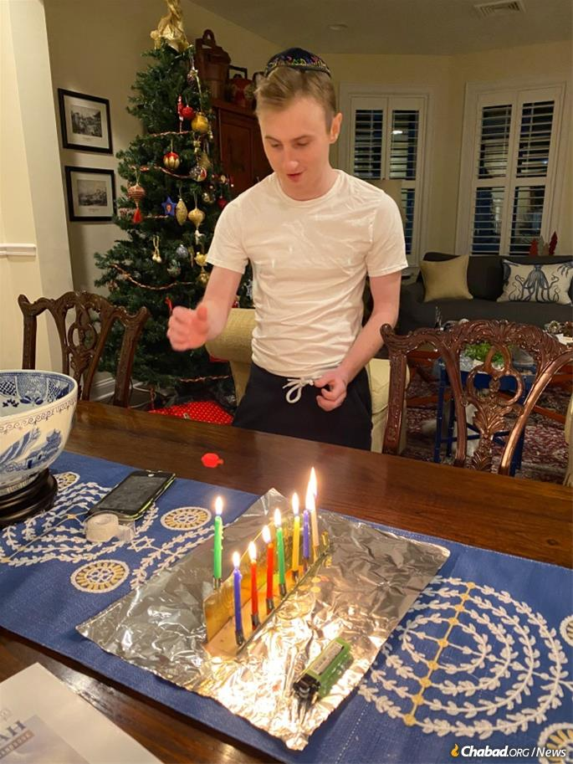
Thanks to a chance visit by Rabbi Levi Lezell, co-director of Chabad of the South Shore, Jimmy Hanley, 21, lit a Hanukkah menorah for the first time in his life.
Sometimes, a small spark can light a fire. It needs the right conditions, of course—time, place and just the right kindling to start things going.
That’s what happened to the Hanley family in the Boston suburb of Hingham, Mass., near the end of 2020 when a Chabad rabbi unexpectedly knocked on their door.

Jimmy grew up in Asia but was always close with his grandmother, Marion Platt, who lives in South Africa.

Their story goes back to when Adrianne Hanley, now 55, was a teenager. A budding figure skater from South Africa, where she grew up in a Jewish home with lots of family nearby, she left the continent in 1983 at the age of 17 for the United States to train and compete. She had her eyes set on the Olympics—practicing 10 hours a day, she recalled—though in the end, that goal didn’t come to fruition.
Instead, she stayed in America, got married and then moved with her husband for his job in Asia, living for decades in Hong Kong, Singapore and Indonesia. They had two sons born there, Aidan, now 27, and James (“Jimmy”), 21, who attended American schools. But Jewish life and amenities then were hard to find, and the boys grew up without much tradition, and did not have bar mitzvah ceremonies.

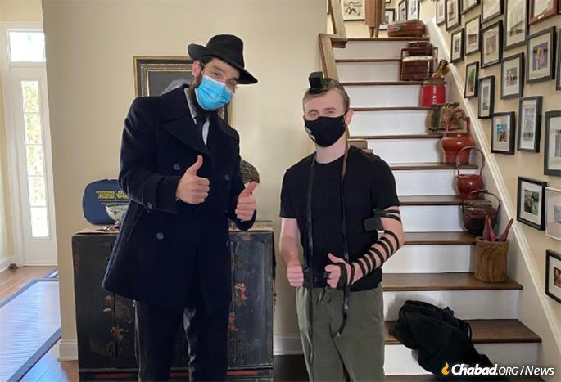
Soon after their Hanukkah encounter, Jimmy put on tefillin for the first time.

“It weighed on me,” said Hanley.“I was always very Jewish at heart and felt strongly about it. Throughout my whole life, I thought of myself as a good Jewish person; I just didn’t do synagogue and everything. I put it off.”
The boys did, however, have the influence of their grandmother—Hanley’s 80-year-old mother, Marion Platt, who lives outside of Johannesburg. They would go to South Africa for visits, and she would come and stay with them for months at a time, cooking traditional foods and imbuing them with a sense of ritual.
“She is the Jewish mother,” described Hanley, “and a real Jewish grandmother. She bakes, tells stories, and over the years formed an especially close bond with Jimmy—an undeniable connection.”
About eight years ago, Hanley—a real estate agent and by then a single mom—moved back to the United States, settling in Hingham. Again, she found herself remote from Jewish life until one day this winter, a rabbi literally knocked on her door.
“I decided to send a Hanukkah package to my neighbor,” recounted Hanley. She happened to order the package, which included a menorah and candles, online through Chabad of the South Shore, co-directed by Rabbi Levi and Mushky Lezell. After dropping off the package on the first night of the holiday, as he did for many others who were isolated during the pandemic, the rabbi decided to go next door to meet Hanley and see if she needed a menorah for herself.

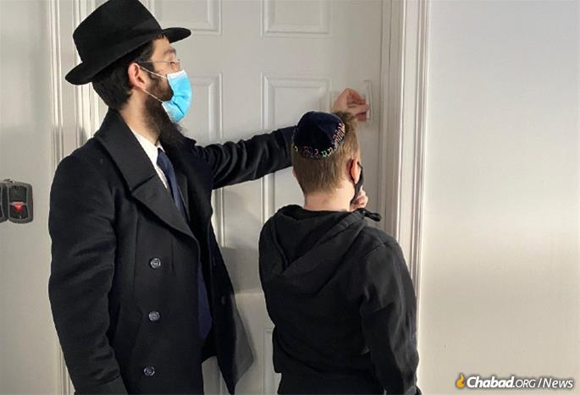
With Lezell’s assistance, the two hung mezuzahs at the Hanley home in January.

Spotting Jimmy inside, the rabbi asked him if he would like to light the candles. So he did, for all three of them. For Jimmy, it was a first.
As his mother watched, she said “that moment, something was lifted from me. It brought so much clarity. It’s been a challenging year, financially and otherwise, due to the pandemic, but at that moment, I knew I was going to be OK. That 2021 was going to be alright.”

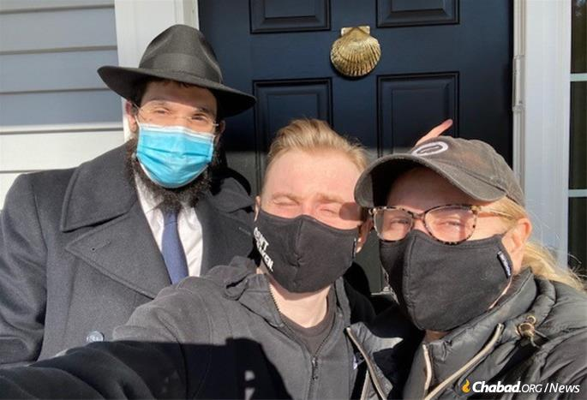
Lezell points to the newly installed mezuzah on the Hanley home with Jimmy and his mother, Adrianne.

The rabbi even managed to get a Hanukkah package to Hanley’s mother in South Africa through Rabbi Ari Kievman at the Chabad House of Johannesburg. Hanley said they sent someone up personally to give it to her, reporting that “she felt incredible. She has been on lockdown in her apartment, and we haven’t seen her in so long.”

‘A Life-Changing Moment’
As for Jimmy, an English major in college now studying at home, the menorah-lighting was so inspirational that he took the next step. With Lezell’s assistance, the two hung mezuzahsat the Hanley home on Jan. 22. He also wrapped tefillin, another first.
The 21-year-old said “it was a life-changing moment.”
“It was uplifting. I feel like this has given me a whole new perspective on spirituality,” he said. “I am excited to see where this goes. It’s an opportunity to discover Judaism and more about myself along the way. And I want to make my South African family proud.”

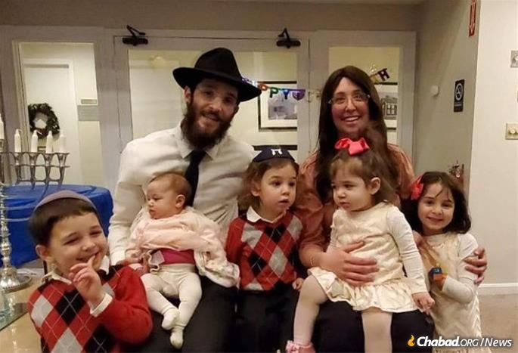
Rabbi Levi and Mushky Lezell, co-directors of Chabad of the South Shore, and their children

Especially, he noted, his Bubba, who they call every day “just to hear her voice.” Jimmy said “she’s very inspiring.”
He explained that growing up, he went to a school that celebrated international religions and cultures; he was exposed to a great deal, though he never really had the opportunity to express his Judaism. Now he is considering learning with the rabbi, as well as joining a Birthright trip to Israel as soon they start up again. Hanley, too, is planning to visit Israel at the end of the year with her mother and other family members, as soon as travel restrictions are lifted.

Now Helping Others to Celebrate Purim
Adrianne Hanley delivers Purim packages to Boston-area Jewish residents with the help of the rabbi and two of the Lezell children, Shterna Sarah, 7, and Sholom, 5, who is carrying a box of matzah for one recipient, a nearly 90-year-old English professor.

She has also started helping with local deliveries of Chabad’s “Loaves of Love” Shabbat packages, as well as mishloach manot for Purim the week before the holiday, accompanied by the rabbi and two of his young children. One drop-off was to a nearly 90-year-old college English professor who has been living alone since the start of the coronavirus pandemic and said he was overjoyed by the visit and, especially, the fresh hamantaschen. He said years ago, his mother would mail him hamantaschen from Iowa, his home state, and the treat would arrive tasty, though rock-hard. They even brought him a box of matzah because he had mentioned to the rabbi how much he likes it.
Lezell said it’s all an example of how “now more than ever, we need to look out for others. When you do your part, you can make a positive impact in another’s life, and the domino effect can be felt across the globe.”
He also noted that the Rebbe—Rabbi Menachem M. Schneerson, of righteous memory—taught that “nothing happens by chance. We are meant to be where we are when we are needed.” As far as the Hanleys are concerned, Lezell pointed out that “there is truly an obvious pattern of Divine organization in the way that we met and the time in their life that we connected.”
Hanley whole-heartedly agreed. It’s not just that she is happy for her son, but for herself. It’s encouraging, she said, recognizing that had it not been for the pandemic and the slower pace at work and home, she probably would have kept postponing Jewish involvement because that’s how life is.
“Before this year, maybe I wouldn’t have been open to it,” she acknowledged. “But the rabbi came at the right place and the right time. I feel like it’s a new beginning. I am so hopeful.”
More than that, she said, “I feel blessed.”

Reprinted from the February 22, 2021 dispatch from Chabad.Org News.

The Power of Pushkas
By Rabbi Dovid Goldwasser

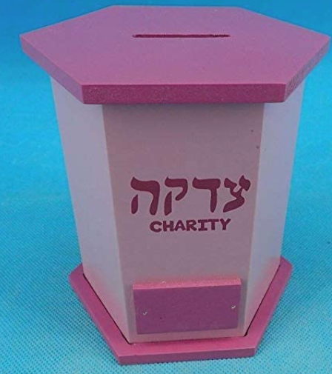

Our sages teach us that the mitzvos of tzedakah and gemilas chassadim are important elements of the teshuvah process. Similar to a korban, tzedakah has the capability to atone for one’s aveiros and has the potential to bring the ge’ulah.
It was customary for the gabbaim in Mezhbizh to place pushkas throughout the shul on Erev Yom Kippur to collect tzedakah before and after Minchah. They would shake the coin-filled pushkas to inspire community members to give tzedakah.
One year, the leaders of Mezhbizh sought to discontinue this minhag. They said it disturbed the congregants, and most people were in a rush to head home to eat the seudah hamafsekes and prepare for Yom Kippur.
However, the Baal Shem Tov rejected the resolution and said there was no way he could agree to annul this holy custom. He explained that one year Heavenly prosecutors erected a wall in Heaven that disrupted the Jewish people’s flow of prayers and prevented them from reaching the Heavenly Throne. The prosecutors could not be removed until the gabbaim began to shake the tzedakah boxes.
There was such a clamor and din that the prosecution became disoriented and dispersed. Only then did the wall come down and were the people’s heartfelt tefillos able to ascend straight up to Heaven.
How great is the power of the mitzvah of tzedakah!
Reprinted from the March 18, 2021 website of The Jewish Press.
What to Look for
In a Good Wife

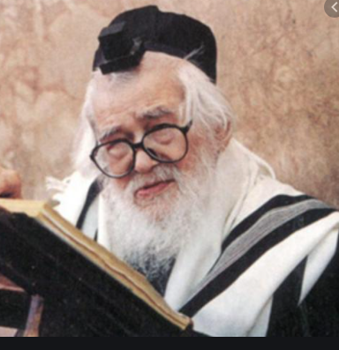

A Yeshivah Bochur once came to Rav Elazar Shach, zt”l, because he was very confused about a possible Shidduch that had been brought to his attention. The girl seemed perfect in every way and was seeking someone who wanted to remain in learning.
The only negative thing he had heard about her was that it seemed to be that she was not very intelligent. This worried him, because he feared that if he married a woman who lacked a sharp mind, they would be less likely to have intelligent children.
Rav Shach explained that raising successful children depends on one thing, and one thing only, and that was how much Yiras Shamayim the parents of the child have.
He said, “How can you know how much Yiras Shamayim a person has? If their every move is calculated to bring pleasure to Hashem and if they are very careful about other people’s money, you can know that they fear Hashem. Another way you can see Yiras Shamayim in the home is when the parents are always willing to give in to one another, and when there is always an atmosphere of joy in the house surrounding Mitzvos. Also, one should be able to see how a person is upset if he falls in Ruchniyus.
The main things to look for in a wife is that she jumps away from Aveirah like from fire. She should love her fellow Jews, perform Chesed, and have good Middos. Most important is that she not be materialistic. This is how you will merit to have children who grow up to be great Talmidei Chachamim and Tzadikim who have profound Yiras Shamayim. The intellectual abilities of the parents are actually irrelevant to the development of the children’s potential. The only thing of real significance is Yiras Shamayim!”

Reprinted from the Parshat Shemini 5781 email of Torah U’Tefilah as compiled by Rabbi Yehuda Winzelberg.

The Power of the
Shehakol Blessing

Rav Elimelech Biderman, Shlit”a, writes that during World War II, Baranovitz was on the border of Russia and Germany. Once, German soldiers ordered all the Yidden of Baranovitz to line up facing a wall.
The Yidden understood what the Nazis were planning. They prepared to leave this world with Teshuvah and holy thoughts. The previous Slonimer Rebbe, the Nesivos Shalom, zt”l, reminisced that his father who was among those standing by the wall, and he asked him for a cup of water, because it is written in Sefarim that it’s ideal to say the Brachah of Shehakol before one’s demise.
His father took the cup of water and said, “Baruch Ata… Shehakol Nihiyeh Bidvaro.” Everyone present heard the Brachah and answered Amein.
Immediately afterwards, gunshots were heard. Russian soldiers had arrived and were shooting at the Nazis. The Nazis ran to fight off the Russians, and in the meantime the Yidden escaped!
People went over to the Nesivos Shalom’s father and said, “You saved our lives! It was a miracle!”
The Nesivos Shalom replied, “It's not a miracle. I said Shehakol and increased my Emunah Peshutah, the simple faith that Hashem does everything. It is Emunah that saved us!”

Reprinted from the Parshat Shemini 5781 email of Torah U’Tefilah as compiled by Rabbi Yehuda Winzelberg.

Framed Pictures of Tzadikim

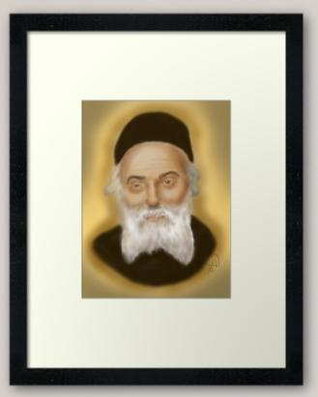

There was once a man who was involved in a serious accident and sustained a trauma which caused him to become severely handicapped, R”L. His only choice was to undergo a special regiment of rehabilitation in a center designated specifically for such situations.
Before he left for the center, he decided to travel to Bnei Brak and receive a Brachah from the Ponovezher Rosh Yeshivah, Rav Elazar Shach, zt”l. After hearing about the man’s handicap, Rav Shach asked him which rehab center he would be going to and when his rehabilitation was scheduled to begin. The man was surprised that the Rosh Yeshivah took such an interest in the minor details, and told him all the information.
Then, Rav Shach gave him a warm Brachah, and the man went on his way. After the man left, Rav Shach turned to one of his attendants and said, “Hurry, buy some framed pictures of the Chofetz Chaim, Rav Chaim Ozer, and the Chortkover Rebbe. Then take them to that rehabilitation center, find out which room this man will be assigned to, and hang up those pictures all over the walls.”
The attendant was puzzled. He asked, “Is all this really necessary?”
Rav Shach simply answered, “When you get there, you will understand.”
Shocked by What He Saw
The young attendant did as he was instructed, bought the pictures of those great Gedolim, went to the rehabilitation center, and was given the man’s room number. As he walked into the room, he was shocked by what he saw— the walls were covered with indecent pictures!
Quickly, he took down the inappropriate photos and replaced them with pictures of Gedolei Yisroel. When he returned to Rav Shach, the Rosh Yeshivah asked him what he found. He told him what he saw and commented with awe and reverence, “The Rosh Yeshivah surely has Ruach HaKodesh, and knows the future!”
Rav Shach smiled and shook his head and said, “This was not Ruach HaKodesh. I just used common sense. Hospitals are filled with sick people who cannot get out of their beds, and all they think about is the pain and suffering that they must endure.

The Danger of Inactivity
“In rehabilitation centers, however, people are generally not bedridden, nor are they in constant agonizing pain. They undergo treatment for a certain number of hours a day while the rest of the time they are bored, and this inactivity makes them even more bored.
“Furthermore, since they are not home in their normal religious surroundings, barriers tend to come down and people are generally more lax in their Mitzvah observance.”
The attendant asked, “If that is so, why didn’t the Rosh Yeshivah just send me to clean up the room before he came?”
Rav Shach answered, “No, no! When barriers fall and Torah becomes weakened, one must rebuild and recreate a spirit of Kedushah and sanctity. Just staying away from evil is not enough. One must actively pursue righteousness by fulfilling the words in Yeshaya (30:20), ‘Your eyes will behold your teacher!’”

Reprinted from the Parshat Shemini 5781 email of Torah U’Tefilah as compiled by Rabbi Yehuda Winzelberg.

The Baal Shem Tov’s
Unusual Marriage
By Rabbi Sholom DovBer Avtzon

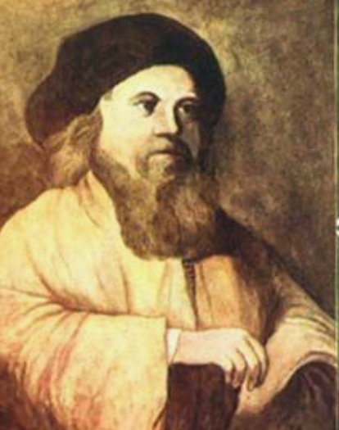

Rav Ephraim was the head of the Beis Din in the city of Brod. Once, he himself was involved in a dispute with another Jew in the city, and both parties had to appear before a Beis din to settle it. To prevent the slightest suspicion that the Rabbonim of the Beis Din were prejudiced toward him, Rav Ephraim agreed to travel with the other party to a distant city where no one knew who he was.
One evening, on their way to that city, they stopped at an inn in a small village. The Baal Shem Tov (the Besht), who was then serving as a melamed for the innkeeper’s young children,^{[1]} saw with his ruach hakodesh that Rav Ephraim’s daughter, Leah Rochel, was destined to become his wife.
Knowing that the Av Beis Din (Chief Rabbi) of Brod would never agree to marry off his daughter to a simple melamed, the Besht decided to reveal part of his true greatness and began a learned discussion with the two travelers involving a deep concept in Torah.
After witnessing his incredible brilliance and clarity of mind, the two litigants said to each other: “Why should we go through the trouble of traveling for another few days when we have a true scholar right here? Let us present our case to him!”

The Besht Agreed to Hear the Case
The Besht agreed to hear the case and settled it to their mutual satisfaction. Rav Ephraim proceeded to have another learned discussion with the Besht, and he was overcome with admiration for his/the depth of knowledge and scholarship of this melamed, who was so young yet so wise. After discovering that the melamed was not married, he asked him if he would agree to marry his daughter Leah Rochel, and the Besht answered in the affirmative.
However, the Besht stipulated that when the tna’im outlining the agreement would be written, no title should accompany his name. “Instead,” he stated, “just write that you arranged a shidduch for your daughter with Yisroel ben Eliezer.” Rav Ephraim obliged and they wrote the tna’im, both of them receiving a copy.
Rav Ephraim took leave of his future son-in-law and prepared to return home and inform his daughter of her wonderful fortune: she was engaged to a remarkable man, a tremendous talmid chochom and outstanding in all other virtues as well. However, since he was the Chief Rabbi not only of Brod but of all the surrounding towns as well, and since he wasn’t expected to return home for another few days anyway, he decided to utilize the extra time to visit some of the nearby villages and affirm that everything was in order.

Rav Ephraim Suddenly Took Ill and Passed Away
As fate would have it, in one of these villages Rav Ephraim suddenly took ill and passed away, without having had the opportunity to inform his family about the wonderful match.
Rav Ephraim’s son Rav Gershon Kitover assumed his father’s position as Av Beis Din of Brod. After getting up from shiva, he was surprised to find among his father’s belongings a copy of an agreement concerning his sister’s engagement. His surprise turned to bewilderment when he didn’t see any great titles written next to the chosson’s name.
“Can it be that the chosson is an unlearned person?” he wondered. Nevertheless, he consoled himself, saying, “My father, of blessed memory, would never have arranged or agreed to such a match, unless the chosson is indeed a genuine talmid chochom. Probably the chosson is not only a true gaon but also extremely humble and did not wish to be identified with any titles.”
Not knowing who the chosson was or where he lived, the only thing the family could do was to wait and see.
Some weeks later, when the Besht concluded teaching his students, he informed their parents that they should hire a new teacher for the next term, as he was leaving town.
Arriving in Brod, the Besht put on the clothing of a simple laborer and went to meet the family of the kallah. Since Rav Gershon had assumed all of his father’s responsibilities and spent most of his day in the Beis Din, that is where the Besht went to meet him.

The “Poor” Laborer Didn’t Come for a Donation
Seeing a poor laborer standing at the door, Rav Gershon immediately instructed one of his attendants to give him some food and money. However, the attendant returned and said: “The person told me that he did not come for a donation, but rather to speak with the Rov about a private matter.”
Although puzzled as to what this could be about, Rav Gershon agreed, and after everyone else had left the room, the visitor entered. Studying his visitor, Rav Gershon saw that as he entered he raised his hand to the mezuzah but did not touch it.
Taking out his own copy of the tna’im, the Besht said, “I am Yisroel ben Eliezer who, according to your father’s agreement, is to marry your sister.”
Rav Gershon was dumbstruck. He couldn’t believe his eyes and ears. “How could my father have agreed to arrange a match with such an ignoramus?!” he thought. “Surely this is a mistake!” However, being a true Rov, he knew he had to investigate the matter and uncover the truth.
Rav Gershon took out his father’s copy and began comparing it to that of the Besht. After a thorough examination of both documents, he saw that they were indeed identical. No, it was not a mistake; his father had arranged an unthinkable match.

Offered a Lot of Money to Annul the Agreement
Quickly composing himself, Rav Gershon offered Yisroel a substantial amount of money to annul the agreement.
“I will not take any money from you,” the Besht replied, “nor would I allow you to go against your father’s wishes. The only one who has the right to make such a decision is your sister, the kallah. Call your sister and I will speak to her for a few moments. If she then decides that she does not want to go through with the marriage, I agree to cancel the shidduch without any payment whatsoever.”
Rav Gershon immediately summoned his sister. When she arrived, he informed her that her chosson had appeared. “However,” he continued with great sadness and dismay, “he is a total ignoramus and seems to be a mere beggar. I can’t understand why Father agreed to such a shidduch. But Boruch Hashem there is some good news: he is willing to release you from this obligation after meeting with you for just a few minutes.”

Revealed Himself to His Future Wife
Moving to a quiet corner out of earshot from Reb Gershon, the Besht revealed to Leah Rochel who he really was. He told her, though, that for the foreseeable future he would have to hide his greatness, even from the members of her own family. In addition, he warned her that during that time they would be forced to live in great deprivation. He then added: “Your brother is wondering why I didn’t kiss the mezuzah. However, he is unaware that the mezuzah is possul.”
Leah Rochel approached her brother, but before she could say anything, he said: “Now that you have met him, you can see for yourself that he is a total ignoramus. Let’s go ahead and cancel the shidduch without further ado. You will surely marry someone much greater than him!”
“Dear brother!” she replied, “Since Father arranged it, he must have seen some special quality in him we have yet to recognize. And if he himself possesses no special quality, perhaps we are destined to have a great son. I am going to marry him and fulfill our father’s wishes.”
Rav Gershon was horrified at her answer, and he tried once more to convince her to change her mind. He then mentioned the fact that when the man had entered the room, he had just raised his hand but hadn’t touched the mezuzah. “You see, it’s not just that he isn’t a talmid chochom,” he bemoaned. “He doesn’t even know the basics of Yiddishkeit!”
Knowing who he really was but not allowed to publicize it, she answered her brother in an off-handed manner: “Perhaps the mezuzah is not kosher.”

Discovered the Truth about the Mezuzah
Hoping to prove her wrong, Rav Gershon immediately took down the mezuzah and checked it. To his horror it was indeed possul, just as his sister had stated, but that didn’t make him change his mind. After all, how could such a person sense something like that? He was still mortified by the match.
Having no recourse, Rav Gershon arranged a modest wedding for them, much smaller than what he would have arranged had his sister married a remarkable talmid chochom. After the wedding, Rav Gershon supplied the couple with enough money to buy a horse and wagon so his brother-in-law could earn a livelihood. Knowing how painful their marriage was for Rav Gershon, they moved away a few months later.

Reprinted from the Parshat Shemini 5781 email of Rabbi Sholom DovBer Avtzon, a veteran mehanech and the author of numerous books on the Rebbeim and their chassidim. He can be contacted atavtzonbooks@gmail.com Adapted from a story of the Rebbe Rayatz.
^{[1]}. Compiler’s note: It’s possible that he was the melamed of the other children in the area as well.
The Midnight Mystery
And the Halted Plague
By Elchonon Isaacs

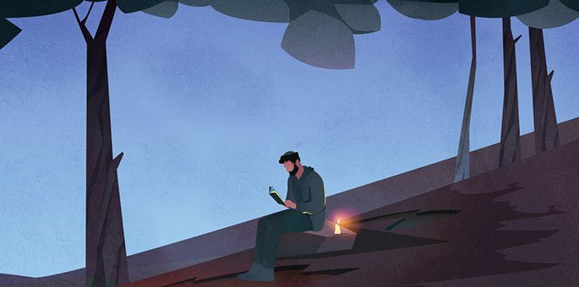

During the years when Rabbi Shmuel Eliezer Eidels (1555–1631, known as the Maharsha) was the rabbi of Ostroh, a deadly plague broke out. The rabbi and the venerable members of the beit din instructed that a day be dedicated to prayer, fasting, introspection and repentance. The rabbi also announced that if anyone knew of issues in the community that needed to be rectified, they should discreetly notify him.
One of the townsfolk lived on the fringes of society and was never seen at the communal prayers. Up to this point, not much attention was paid to this fact, but after the rabbi's request to share any information that could remedy the situation, two townspeople decided to investigate the man and track his whereabouts.
After a few days, they noticed that every night he left his house at midnight and headed to the forest outside the city. They followed him discreetly until he left the town behind, but when he disappeared into the thick forest, they lost him. Minds racing, the duo imagined that he must be up to some nefarious activities, perhaps even part of a band of thieves.

Much to Their Surprise
The next day they shared their findings with the rabbi, as well as their suspicions. Much to their surprise, the rabbi said, “Tonight I will join you, and we will follow him together.”
The scene repeated itself. At midnight the man left his house and began walking quietly towards the forest. Urged on by the rabbi, the small group followed him until he came to a clearing. There he stopped, sat down on a rock, and lit a candle. He then took out a small prayer book and began reciting Tikkun Chatzot, the traditional dirges lamenting the destruction of the Holy Temple, with great fervor.
The three men stood open-mouthed, listening to his prayer. Suddenly he broke out in tears that melted their hearts. But there was something else that struck them; they seemed to hear a second voice reciting the prayer with him.
“This fellow is certainly not a highway robber,” murmured the rabbi. “But who is the second voice that we are hearing?”
When he exited the forest, the three men approached the man. Apologizing for the surprise encounter, the rabbi explained: “Your conduct piqued the curiosity of some members of the community, so we had to track you. Now we ascertained that our fears were unfounded. But please explain who the second voice that we heard with you was?”

Out of Respect for the Rabbi
The man was perplexed by the question, but out of respect for the rabbi, he answered: “It has been my custom for some time now to mourn the destruction of the Holy Temple, and it seems that my prayers caused great satisfaction on high. Jeremiah, the prophet who foresaw and experienced the destruction, joins me on a nightly basis.”
The three of them looked at him in amazement. The rabbi broke the silence and asked: "If you have such a merit, why don't you inquire in heaven as to the reason for the plague in our city? Additionally, why is it that you never join the community in prayer?”
"Tomorrow, I will come to the morning prayer and answer both questions together," the man replied and headed home.
The next morning in the main synagogue, the rabbi watched the door, awaiting the arrival of the hidden saint whom he met the previous night. The prayers began on time, but the man did not show. About halfway through, the man entered while wrapped in his tallit and tefillin.
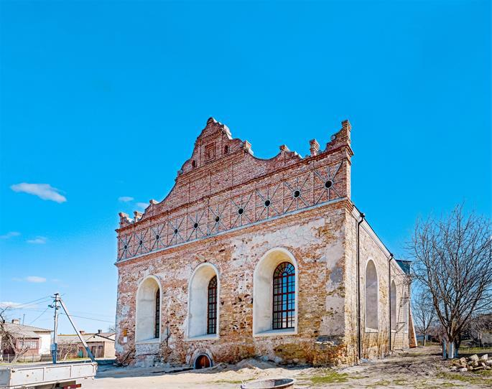
The synagogue of the Maharsha, as it can be seen today, in Ostroh (photo:wiki).
Suddenly there was a commotion in the crowd, and an incomprehensible fear fell on those present. Worshippers who tried to look at him were filled with anxiety and had to take their eyes off him, and some of them even went outside the synagogue to calm down. All the while, the man stood in the corner and prayed devoutly, clearly oblivious to the commotion he was causing.
When the prayers concluded, the man removed and folded his tallit and tefillin. The rabbi approached him and said: "Now I have a third question, what caused the fear when you entered?"

A Reference to the Tefillin
The man explained: "The Torah states: ‘Then all the peoples of the earth will see that the name of the L-rd is called upon you, and they will fear you’ (Deuteronomy 28:10). And our sages note: This refers to the tefillin that are on the head. Thus tefillin causes fear, and that is why fear gripped those who saw me wearing my tefillin.”
"But I also wear tefillin daily," countered the rabbi. “Why is no one awestruck by me?”
"It is because I am careful not to speak anything mundane while the tefillin are on me. I respect the tefillin properly; therefore, their sanctity is preserved. You all fulfill your obligation to wear tefillin, but because you are frivolous, the sanctity of the tefillin is compromised."
The rabbi listened, as did the others. Then the man added: “This is why I do not come to the synagogue, because the masses are not meticulous in respecting the synagogue's sanctity. I do not want to be tempted to speak while in the synagogue, especially when I wear tefillin.”

A Remedy to Stop the Epidemic
After a moment of silence, the man continued. "In my opinion, if this problem will be remedied, the epidemic will stop."
The story quickly spread and all residents agreed to strengthen their commitment to upholding the sanctity of the synagogue and tefillin, and in a few days, the plague stopped.
The residents of Ostroh continued to keep their commitment even after the plague ended and life returned to normal. The synagogue became known as the Maharsha’s shul, after the rabbi, and it was treated with the utmost sanctity.

Reprinted from the Parshat Shemini 5781 email of Chabad.Org Magazine.

18th Century German Hanukah Lamp

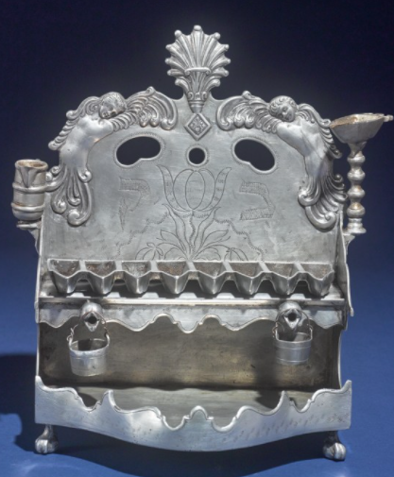
An intriguing Hanukiah from the collection of Arthur & Gitel Marx Collection.
Rav of Komemiyus – Rabbi Binyomin Mendelson

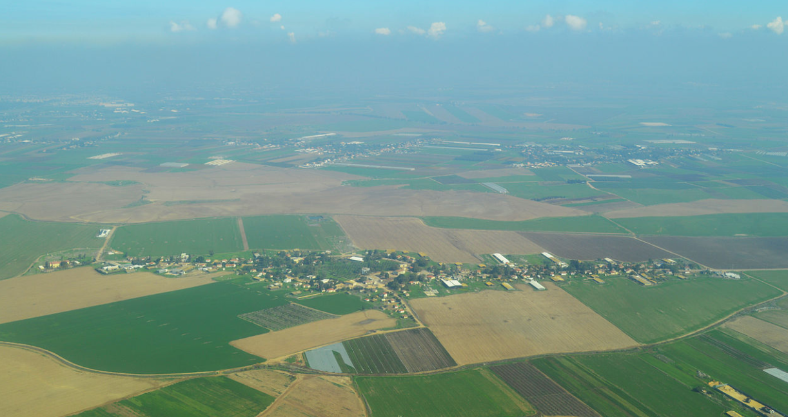
Aerial view of Moshav Komemiyus

His entire life and every action was dedicated to Hashem’s Will; and from that stemmed all of his spiritual greatness. It is difficult to imagine how R’ Binyomin Mendelson achieved greatness in so many capacities – as a Gaon in halacha, a Torah teacher, a Poseik, a Rav and leader of a community, one who deeply loved his fellow Jew, a strong fighter for Hashem’s Will, and many more sterling achievements.

A Beloved Rav
This beloved Rav, who was renowned as the Rav of Moshav Komemiyus, was as distant from our earthly standards as heaven is from earth. Yet he was closely attuned to his people’s needs. A warm and caring chassid, he lived on this planet, but his mind and heart existed in a heavenly realm.
A man of absolute truth, his strong leadership and strict adherence to every halacha fortified Moshav Komemiyus and many other settlements to strictly adhere to the laws of shemittah and other laws of the land of Eretz Yisroel, at a time when it was not prevalent. In his fifty years as Rav, he drew many people closer to Torah and mitzvos.

Following in the Footsteps of a Distinguished Ancestor
R’ Binyomin was born in Plotzk, Poland. He followed in the footsteps of his ancestor, R’ Moshe of Zolshin, author of Mishpat Tzedek on Tehillim, who constantly strove to instill fear of Heaven in the hearts of his followers. R’ Binyomin received his early education from his father, the tzaddik R’ Menachem Mendel, a great Gaon in Torah who would devote every possible minute to learning Torah.
When he would change from one sefer to the next, he would close his eyes and whisper to himself, “I have set Hashem before me always.” R’ Menachem Mendel also taught others, serving as Rosh Mesivta in Plotzk for ten years. He never derived any benefit from this world. He was so highly regarded that many people came to him to ask that he pray for the ill and those needing salvation.
R’ Binyomin’s mother was very righteous, devoting her life to allowing her great husband to learn Torah for its own sake. Their youngest son, R’ Binyomin, was raised in this pure home. At an early age, his father instilled in him the importance of holiness and purity in one’s actions and thoughts, which is a segulah to understanding one’s Torah study and to acquiring fear of Heaven.
Aside from young Binyomin’s outstanding mental abilities, he excelled in his remarkable desire to learn Torah – and he exerted himself to acquire every morsel of Torah, like a thirsty man who cannot seem to quench his thirst. As a young bachur, he had already mastered the halachic seforim of the Noda B’Yehudah and Avnei Nezer, the Talmud Bavli and Shulchan Aruch, the seforim of the Sfas Emes and Yismach Yisroel, and more.

Always Sitting and Studying Diligently
R’ Binyomin was a permanent fixture in the Plotzk Beis Medrash – always sitting and studying diligently, day and night. It was unheard of in Plotzk for one to enter the Beis Medrash and not see Binyomin learning there.
Once someone brought a radio to Plotzk. Being that it was a new invention, everyone ran to marvel at this wonder. Everyone except Binyomin. A friend asked why he was not interested in seeing the radio. “Of course I am interested. But I am far more interested in the words of the Gemara…”
While learning in the Yeshivah in Plotzk, R’ Binyomin once fell ill and was forced to remain in bed for an extended period of time. He utilized his time by thoroughly learning the seforim of the Ramchal (R’ Moshe Chaim Luzzato), which strengthened his faith in Hashem. He was later to draw on this to strengthen the faith of many of his friends and to strengthen himself to face the secular winds which threatened the foundations of Torah in Eretz Yisroel.
When he later settled in Eretz Yisroel, R’ Binyomin would often travel to Teveryah and pray at the grave of the Ramchal to express his appreciation for the immense spiritual gains he derived from the Ramchal’s seforim.

Years of Spiritual Growth
The years R’ Binyomin spent learning in Plotzk after the First World War were years of spiritual growth and preparation for the holy tasks and difficult challenges he would face in his life. After his marriage to the daughter of R’ Aharon Moshe Chaimowitz, a Gerrer chassid, R’ Binyomin settled in his wife’s hometown where he opened and led a yeshivah for ten years. It was a highly organized yeshivah. R’ Binyomin’s great abilities in teaching and understanding Torah were revealed as he guided each student to reach his potential.
The surviving students of the Plotzk Yeshivah always spoke of that golden period of their lives, when they merited to hear the innovative Torah thoughts of R’ Binyomin, from a holy mouth that was fully steeped in fear of Heaven. His Torah remained alive within them even throughout the horrors of the Holocaust.
R’ Binyomin conducted his life in a holy manner. He was a devoted chassid of Ger, who was bound heart and soul to the Imrei Emes, R’ Avrohom Mordechai of Ger. R’ Binyomin was of the few who was capable of recording the deep Torah thoughts of the Imrei Emes. He remained close to the succeeding Rebbes of Ger – the Beis Yisroel, the Lev Simcha – until his final day.

A Prominent Rav and Talmid Chochom
Though he was a prominent Rav and talmid chochom, and Rebbi of many talmidim, R’ Binyomin subjugated himself to his holy Rebbes as a modest chassid among many other chassidim. Upon the advice of his Rebbe, the Imrei Emes, R’ Binyomin ascended from Poland to Eretz Yisroel in 1933 to fulfill the mitzvah of settling in the holy land.
So deep was his love for Eretz Yisroel that he was willing to move there no matter what the cost, and if he would not find a position as Rav or Rosh Yeshivah, he was ready to become a simple storekeeper. His motivation was purely for the sake of Heaven, as was all he did throughout his life.
Before he left, he was offered the prestigious position as Rav of Sanok in Galicia. But his heart was drawn to Eretz Yisroel, and he declined the offer. R’ Binyomin became the Rav of Kfar Attah (now Kiryat Attah) in Haifa. He was a Rav who busied himself with his task at hand and shunned Rabbinical honors. His only guiding light was the Will of Hashem.
With love and endless sacrifices, R’ Binyomin built up and cared for his community. The people loved and respected him; his word was law. His personal schedule was one of discipline and devotion. He spent hours praying with deep fervor and emotion. He learned Torah day and night with great diligence, teaching others both privately and publicly, and recording his Torah thoughts.

Praised by the Satmar Rebbe
The Torah giants of the time recognized R’ Binyomin’s greatness and loftiness. The holy R’ Aharon of Belz said that R’ Binyomin was a Rav on the caliber of the Rabbonim who lived 200 years ago. The Satmar Rebbe, R’ Yoel Teitelbaum, said that R’ Binyomin was living proof that one can properly carry out his responsibilities as Rav in Eretz Yisroel.
The Chazon Ish wrote of R’ Binyomin that “all of his deeds are for the sake of Heaven,” and that he is a “complete tzaddik.” The Brisker Rav said of R’ Binyomin, “His ‘wealth’ is fear of Hashem.”
The light of R’ Binyomin’s Torah greatness shone forth from Kfar Attah to all of Eretz Yisroel. People from far and wide came to him for psak halachah and to conduct Dinei Torah. Many of the most difficult questions and cases were brought to R’ Binyomin. At times R’ Binyomin was asked to serve on other Batei Dinim with the most outstanding Torah giants of the time. But he was not only a poseik. He was not only a Rav.
He was a complete and consummate leader of his people. He cared for every aspect of his community’s needs. When the remnants of the Holocaust reached Eretz Yisroel, R’ Binyomin distinguished himself in becoming like a father to the orphans and a husband to the widows. He exerted himself to help young refugees find shidduchim and establish homes as they had no relatives to assist them. So devotedly did he extend himself on their behalf, that one would think he was closely related to all of these destitute refugees!

Acting Solely for the Honor of Hashem
His strong stance in upholding Torah and halacha as a Rav never diminished his humility, for he acted solely for the honor of Hashem. He once admonished the owner of a bakery about his negligence in certain areas of kashrus. Right afterwards, R’ Binyomin was heard loudly berating himself, “If I myself had not sinned, I would not be forced to admonish my fellow Jew…”
He was never seen preparing to give a public drosha, save for his spiritual preparations. He was heard to whisper to himself right before his drosha, “Hashem, please put the right words in my mouth so that I may reach the ears of those listening…” (Marbitzei Torah Me’Olam HaChassidus, Vol. 8) The yahrzeit of R’ Binyomin ben R’ Menachem Mendel Mendelson zt”l is on 24 Iyar (1979). May his merit protect us.

Reprinted from the Parshas Shemini 5781 email of The Weekly Vort.
True Happiness

Reb Avrohom Dovid Tennenhaus of Montreal was originally a Viznitzer chossid and had become a full-fledged Lubavitcher. He merited a unique relationship with the [Lubavitcher] Rebbe, in which he dared ask what others would not.
He once asked the Rebbe a question that was bothering him, “How is it that Marilyn Monroe, a goyishe actress, earns five million dollars a year, while our mashpia Reb Peretz Motchkin wears a tattered sirtuk [frock coat or Chassidic kapote]. In fact, before he enters yechidus, he borrows the sirtuk of Reb Yerachmiel Binyominson… “Where is the justice?”
Reb Avrohom Dovid continued, “Does the posuk not state, ‘The silver is Mine, and the gold is Mine, says Hashem (Chagai 2:8)?’”
The Rebbe responded, “I doubt Reb Peretz is fully aware of how ripped his sirtuk is. And if he is, it bothers him in ‘his left foot.’ He is truly a happy person. “Whereas this woman, lehavdil, is actually deeply depressed. Despite her great wealth, she has no happiness. In fact,” the Rebbe concluded, “it will soon be apparent…”
A few weeks later, this woman, who was in her thirties, committed suicide. (Tevel Berachvei Hachassidim Otzar)

Reprinted from the Pesach 5781 edition of The Weekly Farbrenen.

Kashrus and Chalav
Yisroel (Jewish) Milk

The Chasam Sofer once asked two community activists to set up a meeting with the mayor of Pressburg. "The issue is urgent, so schedule the meeting immediately."
The delegates asked the mayor's secretary to schedule a meeting for that very day, but the secretary replied, "All slots are filled for today. You can't get an appointment on such short notice. If you want, we can schedule it for next week…" The delegates explained to the secretary that the matter was urgent, and it couldn't be postponed. It wasn't easy, but with their determination and efforts, a meeting with the mayor was arranged for that very day.
They entered the mayor's room, and the mayor graciously offered them a cup of coffee. "No, thank you," they replied.
"Why not?" the mayor asked. "Is it because it isn't kosher?"
That was the reason. The milk wasn't chalav Yisrael [milk from a cow under Jewish supervision].

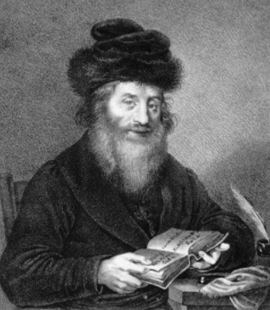
The Chasom Sofer

The mayor went into a rage. "If I offer you a drink, you should accept it!" he said. As he was ranting and raving, the secretary opened the door and asked the mayor whether he had a cup of coffee.
"No. The mayor replied angrily. "I was about to, but these fellows ruined my appetite. I offered them a coffee, but they declined… because of kashrus."
"Good," the secretary replied. "I'm glad you didn't have a coffee because the milk is contaminated. Some people who drank from this milk got sick, and the doctor checked the milk and determined that it is unhealthy.
The mayor immediately changed his tone of speech, and he spoke with the two delegates respectfully. He told them, "I always admired the rabbis of the Jewish nation for their superior wisdom. I forgot about that, of late, and I was considering banishing all the Jews from Pressburg. But now that you reminded me of the wisdom of the Jewish sages, and I will cancel that decree."
The two delegates returned to the Chasam Sofer and told him what happened at the meeting. The Chasam Sofer replied that there was a kitrug in heaven on the Jewish community because they weren't careful enough with kashrus and with חלב .ם"עכו [avoiding milk of the goyim].
In the merit of the delegate's mesirus nefesh to keep the laws of kashrus, the decree was abolished. (Heard from Reb Elchanan Halperin zt'l of Radumishla, who heard it from his father-inlaw, Reb Shmuel Unsdorfer zt'l, a descendant of the Chasam Sofer.)

Reprinted from the Parshas Shemini 5781 email of Torah Wellsprings

A Grandfather’s Defining Moment of Truth

There is a story in Rabbi Nachman’s book Incredible! about a man named Joe Wallis. Joe was on his way home from work when he stopped by The Elephant Steakhouse, an unkosher restaurant in Tel Aviv, to get take-out for his wife and children. He could hear the sizzle of grilling meat and frying onions. He looked up at the pictures of food displayed above the counter, “Pork in pita,” he thought. “The kids are going to love it.”
He waited on the line to place his order, and as he stood surrounded by laughing people, he began to daydream. The steakhouse slowly faded away while a story he heard when he was a young child popped into Joe’s head. It was a story about his mother’s father, Rav Winkler.

The Grandfather’s Backkbreaking Work
When the Nazi came to Hungary and took the family away, his grandfather was sent to a labor camp instead of Auschwitz. The Rav was condemned to backbreaking work, terrible abuse, and starvation. Although almost everyone around him ate whatever they could lay their malnourished hands on, Joe’s grandfather never defiled his mouth with non-kosher food.
Time passed, and the inmates were gathered in a circle when the SS officer in charge began to speak. “Germany has lost the war,” he said. “The Russians will be here momentarily. You are about to become free men again. You will be reunited with your wives and children if they’re still alive. But before you leave, before we unlock the gates, we have one final test. We’ve heard your Rabbiner Winkler is a man of principle. We need to find out just how strong-willed he is.” The Nazi grabbed Rav Winkler and maneuvered him forcibly to the center of the circle.

Challenged to Take Just One Bite of Pork
“Rabbiner,” the Nazi addressed his prisoner, “You want to go home like everybody else, don’t you?” The Nazi motioned to one of the officers, who walked over carrying a plate with a solitary piece of pork. “Rabbiner, the moment you take a bite of this pork, you’ll be freed. You’ll walk through the gates and go home. Otherwise you will be killed in this camp. The choice is yours. One bite is all it takes.” No one breathed as they waited. One bite of pork suddenly equaled life. What would the Rav do? “I will not eat this pork,” he said. The German shot Joe’s grandfather, and he crumpled to the ground, the final Jew to perish at that camp.
Joe came back to himself. “What on earth am I doing here, waiting to purchase meat my grandfather would rather die than eat? And I’m feeding this food to my wife and children when I have the means to buy any type of food?” Joe stood in the middle of that busy, cheerful, unkosher restaurant, unaware of anything but the incredible argument taking place within him. On that humid summer evening, something changed in his heart, and Joe Wallis walked out of The Elephant Steakhouse with empty hands.

Touching and Transforming the Lives of Many Jews
Joe, now Rabbi Yossi Wallis, became CEO of Arachim, the ultra-successful global kiruv organization. Rabbi Wallis has touched and transformed the lives of tens of thousands of Jews and has developed personal, warm relationships with many of our greatest Torah leaders, all because of an unexpected discovery of his Torah heritage while waiting in a restaurant for his unkosher sandwich.
May we all realize that Hashem truly runs the world and learn from Aharon to immediately accept Hashem’s Will with joy. May we also strive to keep the kashrut laws as it is written in our holy Torah, because those laws elevate us both in body and soul. May we see the arrival of Mashiah speedily in our days! Amen!
Reprinted from the Parshat Shemini 5781 email of Rabbi Amram Sananes as written by Jack E. Rahmey.

The Wisdom of Rav Gamliel, Rabbi Blech and the Rebbe
By Daniel Keren

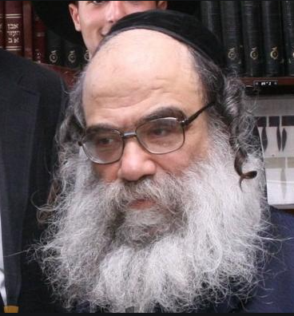

(Rav Gamliel on the Parashah – Sefer Vayikra: Wisdom, Stories, and Insights by the Tzaddik and Mekubal HaGaon HaRav Gamliel HaKohen Rabinovitch, Shlita, hardcopy, 403 pages, translated by Rav Shmuel Winzelberg)

In recent years, English-speaking readers have been blessed with the opportunity to access the unique and valuable Torah insights of Rav Gamliel HaKohen Rabinovitch, shlita, a world renowned tzzaddik and mekubal who is the Rosh Yeshiva of Shaar Hashamayim Yeshiva in Yerushalayim as a result of the devoted efforts of Rabbi Shmuel Winzelberg to translate his teacher’s Torah wisdom into English.
In five separate volumes, Rabbi Winzelberg has made accessible to English readers the wisdom, stories and insights of Rav Gamliel on the Chumash; as well as four volumes on the Moadim (Chanukah, Pesach, the Three Weeks and the Yamim Noraim and Sukkot), and five other volumes on the Essence of Chinuch, Emunah, Kibbud Av Va’Eim, Marriage and Tefillah.

The Third Volume of the Chumash
I recently purchased Rabbi Winzelberg’s translation of Rav Galmliel Rabinovitch’s insights on Sefer Vayikra insofar as we are reading the parshiots (Torah portions) in this third volume of the Chumash. It is clear that the translator has a deep respect for the Torah teachings of Rav Gamliel and has devoted many hours to try and carefully relay these unique Torah concepts from its original Hebrew lectures.
Rabbi Winzelberg’s efforts have resulted in an enjoyable and easy-to-read sefer that captures the unique flavor of Rav Galmliel’s Torah insights that can be comprehended by any reader ranging from a novice to Torah studies and to a Ben Torah with many years of intense Torah learning.
This volume – Rav Gamliel on the Parashah – Sefer Vayikra – can be purchased in Jewish bookstores or from various online outlets. For those readers who are fluent in Hebrew, there are more than 200 shiurim (lectures) of Rav Gamliet Rabinovitch that can be accessed on the popular Torah website – Torahanytime.com
Many times when I am involved in mundane activities like cleaning the house or cooking meals, I utilize Torah websites such as Torahanytime.com to listen or watch fascinating Torah lectures that make otherwise boring duties become more interesting and enjoyable.

A Chasid in Camouflage
One of the more enjoyable Torah programs I have recently seen and highly recommend to readers is A Chasid in Camouflage – Rabbi Benjamin Blech, a 58-minute video in which Rabbi Blech, a world renowned Modern Orthodox rabbi (longtime rabbi of the Young Israel of Oceanside and professor of Talmud at Yeshiva University) and prolific author of dozens of popular books on various topics of Torah and Judaism discussed his most unusual encounter with the Lubavitcher Rebbe, zt”l (Rabbi Menachem Mendel Schneerson) in 1989.
Just as he was about to enjoy a long-deserved Sabbatical from his teaching duties at Yeshiva University and his rabbinical responsibilities at the Young Israel of Oceanside, Rabbi Blech received a quite unexpected phone call from the office of the Lubavitcher Rebbe in Crown Heights. He was told that the Rebbe wanted to meet Rabbi Blech and that he wanted him to go on a four-month visit to the Far East where he was to deliver inspiring lectures at Chabad Centers.
Rabbi Blech asked if perhaps this was a mistake as he was not a Chasid, but a very Modern Orthodox rabbi. He was told that the Lubavitch headquarters knew everything about him and the Rebbe had not made a mistake in selecting him to go on this special lecture tour.

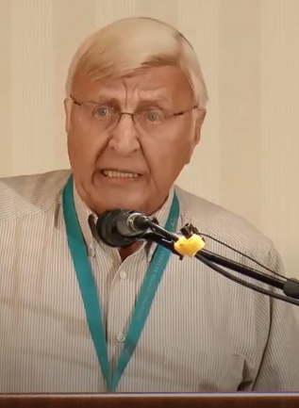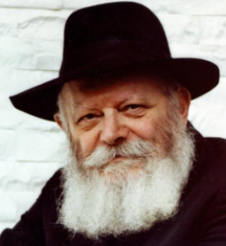
Rabbi Benjamin Blech and the Lubavitcher Rebbe

As a result of the advice the Lubavitcher Rebbe gave him, Rabbi Blech admitted that it changed his outlook on Jewish identity forever, and inspired his philosophy of a Jewish solidarity that disregards our individual differences.
After concluding his lecture tour to Chabad Centers in the Far East, Rabbi Blech made a follow-up visit to inform the Rebbe of what he did had done and what he had observed. The Rebbe in addition to telling Rabbi Blech that he saw him as a Chasid in Camouflage asked his “unusual” chasid if there was any way he could help Rabbi Blech. Rabbi Blech brought up the fact that he had a daughter who was getting a little older and requested a brocha (blessing) that she should find her bashert (husband.) To find out how that brocha worked out, why not google – A Chasid in Camouflage – Rabbi Benjamin Blech.

Reprinted from the April 16, 2021 edition of The Jewish Connection.

Rabbi Eliezer Silver and the Mikveh for the Refugees

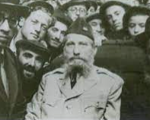
Rabbi Eliezer Silver, zt”l visiting survivors of the Holocaust

During World War II, the American government enacted a rescue commission known as the War Refugee Board which achieved a few notable results (although not as much as it could have), including the rescue of over 100,000 Jews and the distribution of vital relief services when the war ended.
In one unique instance, roughly 1,000 refugees were brought from Italy to Fort Ontario, an abandoned army base near Oswego, New York. Vaad Hatzalah, the Orthodox relief organization, offered a wide range of support services, a model for its postwar efforts.

Three Hundred Torah-Observant Jews
Among the refugees were 300 Torah-observant Jews. The Vaad promptly met their basic needs: kosher food, talis, tefillin and a shul in which to pray. At first, only Orthodox refugees registered for kosher food. Yet, as word of its superior quality spread, the number of registrants doubled. How could the Vaad refuse? After all, Jews wished to eat kosher. The Vaad was delighted.
In time, a second kosher kitchen was established, and a Talmud Torah for the children. The camp’s needs increased daily and the refugees requested an eruv in order to carry on Shabbos. The Vaad had no difficulty taking care of that need to the great appreciation of the refugees.
The next request, however, was not as simple - the Jews insisted that they need a Mikveh, to ensure spiritual sanctity in their homes. The Vaad was happy to oblige but before they could anything, they needed to explain the concept and importance of a Mikveh to Mr. Joe Smart, the Christian camp director. Without his approval, nothing could be done.
The Vaad asked R’ Eliezer Silver zt”l, a ranking member of the Vaad and the chief rabbi of Cincinnati, Ohio, who had come to visit the refugees and offer them encouragement, to represent them in their attempt to procure permission for this endeavor.

Translating the Word Mikveh into English
R’ Laizer was eager to be of assistance. The word Mikveh needed to be translated into English, and one way to do this was to use the word ritualarium, which had been coined earlier while building Boro Park’s first mikveh.
“A ritualarium,” R’ Silver explained to Joe Smart in his heavily accented English, “is a bath where Jewish men and women immerse themselves for religious purposes. Separately, of course.”
Smart nodded knowingly. “What you need is a swimming pool,” he said chirpily.
R’ Laizer shook his head indicating that a swimming pool was not acceptable. He decided to try to explain the concept of a Mikveh, by showing Smart how to build one.
“Okay. First,” he said, “the Talmud requires that a Mikveh must have at least 40 se’ah (a minimum of 648 liters) of water.” Smart shrugged unknowingly. He had never heard of a “se’ah.” But R’ Laizer didn’t notice.
“Also, the space is measured in amos (cubits).” The camp director looked around, helplessly lost in the terminology, searching desperately for a translator. But R’ Laizer would not let him go. “Amos ... you know, forearms, forearms. It’s measured in cubits - about the length of a forearm.” He stretched out his right arm as if to demonstrate the exact dimension in true life.

No Idea about What the Rabbi was Talking About
Joe Smart immediately demurred, taking the matter on faith. “Rabbi, it’s okay. Amos .... cubits, that’s fine.” Joe realized that the diminutive rabbi had already drawn a crowd. And he still had no idea what the man was talking about! “Okay,” R’ Laizer said, “now the water. A Mikveh needs natural water.” He began making flowing gestures with his hands. Displaying enormous patience, Smart smiled, “All water is natural. You want us to pump water in for your Mikveh, right?”
“No, no,” R’ Silver shouted, arms flailing in all directions. “Still, natural water. A Mikveh cannot have water collected from a pipe. The water must be obtained from the sky or a river. It has to be still and natural.”
Joe Smart sighed and gave up. He could not grasp the details and really had no clue what this eminent rabbi was talking about. Shrugging, he motioned to a couple of army engineers standing nearby. “Do whatever the rabbi says,” he said, and slowly backed away.
The engineers had not been part of the conversation before and now ambled over to the short man with the top hat and long coat. Before they had even reached him, R’ Laizer launched into a discourse on amos, forearms and natural water, to the utter surprise and bewilderment of the new arrivals. R’ Eliezer Silver persevered, and in two weeks there was a Mikveh!

Reprinted from the Parshas Tazria-Metzora 5781 email of Torah Tavlin (compiled by Rabbi Dovid Hoffman).

An Italian Bronze Tankard-Form Charity Container

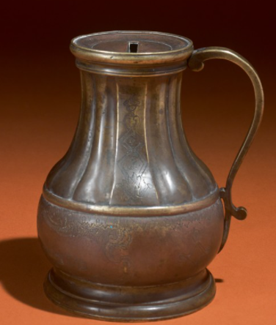
This 18th Century Judaica item from the Arthur and Gitel Marx Collection sold at 2019 Southeby’s Auction for $11,875.
Shabbat is Sacred

Years ago, two brothers from the community owned a jewelry store in Williamsburg. Erev Shabbat, the alarm company called one of the brothers to notify him that his safe was triggering the alarm, because it was left open.
The brothers contemplated asking for a heter—allowance in order to get a car to Williamsburg to check on the safe, but they were uncomfortable with the idea of desecrating Shabbat, no matter what the issue. They decided to ignore the alarm company’s warning.

Every Hour They Got a Call from the Alarm Company
All through Shabbat, the men tried to enjoy like it was any other, but every hour, the alarm company called their houses and left messages saying that the safe was open. They had emunah that everything would be okay, and they took their time and waited until a few hours after Shabbat was over to go check on the safe.
When they got there, they saw the store had been robbed. Jewelry cases were broken, glass was everywhere. One of the brothers went to the safe and prayed that nothing was taken from it. The items in the displays were just the tip of the iceberg to what was inside the store’s safe. Baruch Hashem, the safe was locked, and everything inside was intact. The police were at the store, and they asked the owners why it took so long for them to arrive, as the robbery had been the night before. The brothers explained it was the Sabbath, and they couldn’t come in order to keep the day sacred.

The Amazed Police Officer
The police officer was amazed. “Come with me,” he said to them. He led the men upstairs, where he directed them to a hole in the floor, with some protruding wires, abandoned guns. and a perfect view of the safe.
“You see,” said the officer, “These men that came were professionals. They played with the wires to trigger the alarm. Once the owners showed up, they would open the safe to check on its contents, and the burglars would shoot them and clear it out. They triggered your alarm every hour to get you here, and you didn’t come. If not for your Sabbath, you would’ve lost your money, and your lives.”

Reprinted from the Parshat Beshalach 5781 email of Jack E. Rahmey as based on the Torah teachings of Rabbi Amram Sananes.

The Crying Woman and
The Jerusalem Tzadik

During the early 1900’s Rabbi Yosef Chaim Sonnenfeld (1848-1932) served as Chief Rabbi of Jerusalem. He lived in the Old City but would travel anywhere to perform a berit milah. One day, Reb Yosef Chaim was asked to perform a berit milah on an infant whose parents lived in one of the poverty-stricken areas of the city.
On the designated day, he made his way to the neighborhood of the young couple. He knew there would be very few people at the milah, for the family had no money to tender a festive meal afterwards.
As Reb Yosef Chaim entered the courtyard of the apartment complex, he heard a baby cry. The sound was coming from the building where the milah was to be. He followed the voice and knocked on the door.
A young woman answered the door. “Mazal tov,” said Reb Yosef Chaim. “I am here to do the berit milah for your son.”
“Oy, Rebbi,” sighed the woman. “I only wish you were in the right house!”
Seeing the great Rabbi unexpectedly, the woman started crying. “Rebbi, I have been married so many years and my husband and I have no children. Please bless me.” Then she added, “The child is next door; it’s my neighbor who had the baby.”

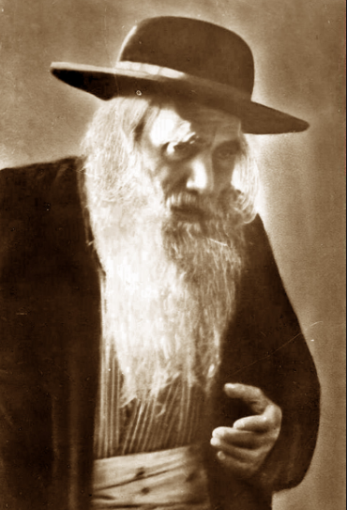
Rabbi Yosef Chaim Sonnenfeld
She turned away, wiping her tears in embarrassment for her brazenness in asking the great sadik for a berachah. She was ashamed that she had broken down and revealed her plight.
Reb Yosef Chaim felt terrible that he had been the cause of the woman’s anguish. By walking into the wrong apartment he had inadvertently brought forth her sad situation.
Reb Yosef Chaim said softly and compassionately, “I give you a berachah that I should come back to your home next year and it won’t be a mistake. It will be for a simchah.”
A year later the woman had a little boy, and Reb Yosef Chaim was called to perform the berit milah. It was the only child the woman ever had. (Reflections of the Maggid)

Reprinted from the Parshat Veyera 5781 email of Shabbat Shalom from Cyberspace as compiled by Rabbi David Bibi.
The Fancy Glass of Water
Rav Yisroel Salanter, zt”l, once left his family and students to go to Paris to try to influence the assimilated Jews there to return to Torah Judaism. One day, he entered an elegant hotel to meet some wealthy Jews who frequented that hotel. He sat down in the lobby and ordered a glass of water.
When the waiter brought him the bill, it was for an exceedingly high amount of money, and he asked the waiter why the bill was so high, simply for a cup of water.
The waiter responded that Rav Yisroel was not paying merely for a glass of water. The charge included the surroundings and ambience in which he drank the water. He was paying for the exquisite furniture, lighting, carpeting, and stunning surrounding view, as well as the water.
Later, Rav Yisroel wrote the following letter to his students: “For a long time I have been puzzled by the fact that we recite a very lofty and all-inclusive Brachah for a plain glass of water. We say, ‘Shehakol Nihiyeh Bidvaro’, which means that through Hashem’s word, everything came to be.
“But from the words of a gentile waiter in Paris, I learned that we are not merely thanking Hashem for the glass of water, we are expressing our appreciation for the magnificent surroundings in which Hashem serves the water to us. We are thanking Hashem for the fresh air we breathe as we drink that water, and for the sun that gives us light, and for the tree that shades us. In short, whenever we thank Hashem for one thing, we should use it as an opportunity to thank Hashem for everything!”

Reprinted from the Parsha Mikeitz 5781 email of Torah U’Tefilah as compiled by Rabbi Yehuda Winzelberg.
Shira’s Unexpected Miracle

Shira was 18 years old when she started searching for the meaning of life. She read a lot and was always trying to find her way, when she finally came to Judaism. After a long period of personal empowerment, she decided to become Frum.
At first, she did everything quietly, and this did not bother her parents. They thought that there was nothing wrong with a little tradition. But then, later, when the family began to realize that Shira was serious about her religious observance, they began making things extremely difficult for her. This was a great challenge for Shira that she tried very hard to overcome.

The Mysterious Unplugging of the Shabbos Hot Plate
For example, the hot plate that she prepared for Shabbos was mysteriously unplugged, and she was forced to eat cold food throughout the entire Shabbos. But she remained determined, and decided not to give up. Shira sometimes would have tears in her eyes because of the difficulties she had to go through, but she kept strengthening herself by reminding herself that she used to be like the rest of her family too, and she hoped in her heart that one day, they too would see the light and truth.
At a certain point she starting hoping for the day in which she could leave her current home, and build a home of her own with her husband, in which they would observe Torah and do Mitzvos with joy. As soon as she felt ready and started dating, an additional difficulty began to develop.

Father Became Enraged Over Shira’s
Plan to Marry a Boy Who Learned Torah
Shira’s father, who knew that his daughter wanted to marry a boy who learned Torah, became enraged with what she was looking for, and told her that a boy like that will never step foot into his house, no matter what! One day, Shira’s father made a call to his wife, but by mistake, he dialed the wrong number. Without realizing his error that he called the wrong person, he automatically began speaking to the woman who answered in Bucharian, the native language spoken at Shira’s house, and the lady on the other end of the line, surprisingly, responded to him in the same language!
The father quickly apologized, and a split second before the conversation ended, the father asked the woman out of curiosity what her last name was, as Bucharians all seem to know each other. From that point, they started conversing, and somehow, the conversation lead to the father telling the woman that he was having a very difficult time with his daughter, who had become religious.
To his amazement, the woman began telling him that she too had a son who was driving her crazy with his religious observance, and how he studied in Yeshivah all day!
An Astonishing Phone Call
Shortly after this conversation, to Shira’s astonishment, she received a phone call from her father, who informed her, without much information, that she would be having a date on the following day with this boy. Shira, who expected to encounter someone who met her father’s expectations, was shocked to see a Yeshivah boy arrive for the date, just like she had wanted all along!
After several dates, the couple announced their engagement! As it turned out, for the first time in his life, a real Yeshivah boy stepped foot in her father’s house, dressed in a black suit, a white shirt, and a hat. At the moment that happened, countless memories crossed Shira’s mind of the times her father warned her not to ever bring home a Yeshivah boy. And in truth, she never did. It was her father who had brought him home! Today, they are happily married for many years, and live in Israel happily raising their family!

Reprinted from the Parshas Mikeitz 5781 email of Torah Sweets Weekly.

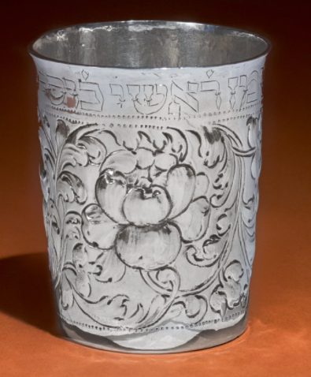

A 17th Century German Kiddush Cup, circa 1660-70 that was auctioned by Sotheby on Nov. 20, 2019 from the Arthur & Gitel Marx Collection for $6,875.

